OK - I have a question regarding manuals - since I've seen two different numbers popping up.
I checked Motorola parts, and found the following:
MAN INSTR 900MHZ MSF5000 DEPOT 6881092E90
Is this the manual I need, or is the other number (the one ending with E70) the proper one???
Sorry for my delay in getting involved with these, but I've been laid up in the hospital all week... ARRGH!!
Thanks!
_________________
Mark - N9WYS
Mark, The manual i have has a part number on it of
68P81064E70-B MSF5000 Trunked Repeater and Repeater (RT) Stations
and this covers 935-941 tx and 896-902 rx.
Guess you got rid of some stones
Feel Better.
Bob P W2YMM
_________________
Robert Prybyzerski Jr
W2YMM
http://www.w2ymm.net
Echolink 1224 / IRLP 4265
Cell 631-960-1051 LI NY
OK - I have a question for Tony, John and others here who obtained these machines. I've looked at one of these so far, and I think I'm looking in the correct location regarding U831. In the machine I've looked at, all I see is a socket - no chip at all. There are the two vertical "red and white" boards to the right (as described).
I guess my question is: WTF??? Will these operate without the EEPROM totally? If not, why would someone pull it? I have a photo of this, but can't figure out how to get it to you to see.
_________________
Mark - N9WYS
w2ymm wrote:
Here is a picture of the u831 chip if anyone is interested in seeing it.
Quote:
I have the IC number,
Its motorola part number
5182335V01
its a EEPOT 50K 10% _9312_
that is whats listed in the book for a U831 ic that was cut
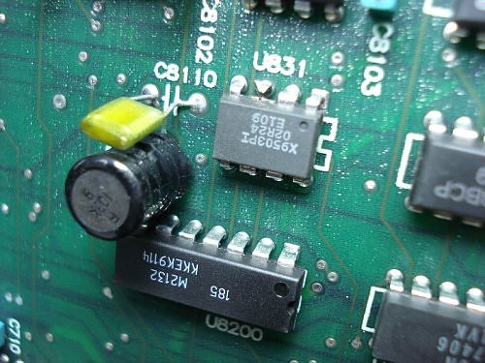
Bob - can you give me a wider shot of this location? I think I'm looking in the wrong place for this chip... Thanks!
_________________
Mark - N9WYS
Here you go Mark, It on the control shelf as you flip it up.
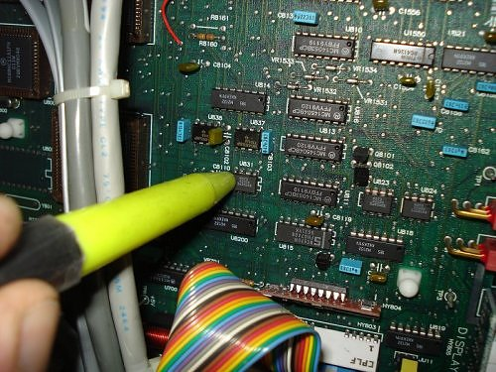
_________________
Robert Prybyzerski Jr
W2YMM
http://www.w2ymm.net
Echolink 1224 / IRLP 4265
Cell 631-960-1051 LI NY
THAT'S the ticket!! Many thanks, Bob!
_________________
Mark - N9WYS
willbartlett wrote:
10 MHZ is a no-go. Too bad. In addition, there is a regulator board present in the PURC5K HSO boxes, so you'll want to breadboard something to regulate to 12v and add a significant amount of EMI filtering as well. Common and differential mode would be advisable. I'll try to get pictures and schematics from the PURC manual as a guide.
Anybody formed a yahoo or google group yet?
Will
Will - anything on the voltage regulator breadboard write-up, or a schematic/photo from the PURC5000?
I'll be getting my HSO sometime next week from Alltronics. I FINALLY wrestled one of these machines into the shack so I can start "deconstruction" of the cabinet... Mine still had the shipping bolts in the HSO drawer - complete with the "Remove when unpacked from carton" tag!
Thanks!!
_________________
Mark - N9WYS
Well, I finally got a chance to dig into the MSF5000 a bit... I checked the HSO drawer and found (I think) the voltage regulator circiut previously mentioned as being in the PURC5000. In tested it and found 15.6V, 9.6V and 3.3V on the board - bit nothing like what the Vectron HSO wants (+12V and +5V, +/- 5% ).
I thought of using a computer power supply, since they supply both regulated +12 and +5V, but I can't seem to figure out how to make one work unless it is plugged into a motherboard.
So it looks as if I'll be building some sort of voltage regulator board. If someone can save me the work of having to reinvent the wheel, I'd be much obliged...
Thanks in advance.
_________________
Mark - N9WYS
Radio Shack 7812 12 VDC regulator...about 2.49. Pick up the power in the drawer, up to 35 volts in gets 12 out at 1 amp.
Thank Tony...NN1D
Works for him, and I will wire the same thing tommorrow...
rrfd43

Hey guys, question on the station controller. When you first turn the unit or, power it up, should every single LED on the controller light up? When I switch my unit on only the fail, line ptt, fail soft, and trc encode comes on and then all go off. None of the green leds for PA operation or rx-tx lock come one at all. Clearly these would not be on unless it was transmitting and the station was VCO locked on RX and TX, but shouldent they come on for a few seconds upon power up? If someone could let me know how their machine starts up it would help me out. Thanks
Mastertech

When you first plug it in, ALL of the LEDs on the TTRC will turn on. As the station goes through its tests, the LEDs turn off one at a time, from right to left. They will all be off under normal operating conditions.
On the SSCB, ALL of the segments and decimal points on the display will turn on. None of the other LEDs turn on. Then the red DISABLE LED turns on and the station goes through its tests, showing various items on the display. When it's all finished, the DISABLED LED turns off, the two green VCO LOCK LEDs turn on, and the display shows "11 ". After a few minutes, the display reverts to just the three decimal points.
For more information on the display sequence during turn-on, you'll just have to go read about it on the web site mentioned at the right of this post, in nice big red letters. That's the site no one here seems to know anything about, but it has all sorts of good up-to-date information that's NOT cast in stone.
Bob M.

Mastertech,
when you have the proper 5 mhz ref osc injected into the proper cable, the MSf
when locked and will show 2 green LEDs a RX and a TX on a idle status
when it transmitts you will see 4 LEDS
if the Rx is unlocked the green RX led will be off,
to put the rx in the ham bands you must first lock the VCO by twisting the operate/transit knob
into the transport posisition then by using the same allen key for tuning the front notch/pass filters
turn the VCO adjustment a half a turn upwards untill the Rx lamp on the front panel goes on, its about a half a turn
this is crude but effective
Tony
NN1D
Tony and group,
I was just reading some of your trials and tribulations with the msf stations. I was looking at the previous post about getting a lock light on the VCO's. Your lock lights will come on long before the required voltage is obtained, shooting in the dark and just guessing with the msf's is going to mess you up. as many will attest to.
Doug
I'm not looking to ruffle an features or anything I'm just trying to save you a bunch of aggravation.
_________________
May the Schwarz be with you.
Doug

I think if you look at the datasheet for the 7805 and 7812, you should see an example sheet. It will include some capacitors. I would follow this as an example. The better filtered the power supply going to the oscillator, the happier you will be in the end. I would strongly advise against using a PC power supply. While they meet some kind of radiated and conducted emissions standard, electricaly they're noisy as hell. you might not get a lock of the switching noise were strong enough, they could cause the oscillator to modulate. It's one of the reasons your HT will hear all kinds of birdies around computer equipment.
The stations have 70 amps of very quiet linear DC available. There should be sufficient current capacity available inside the PLL/14.4 mhz chassis to regulate and supply to the HSO. I'd start there, breadboard the 2 regulators with bypass and common mode capacitors, and you should be very happy in the end. I suggest making sure that the power supply with the fans on it is not the supply feeding the RF shelf or HSO. I think they were cabled with the Fans on the lower amp supply and the rest of the station on the upper amp supply.
I've spent way too much time chasing spurs and other crap caused by poorly filtered switch mode supplies to let anyone else pull what little hair they have left out trying to fix a noisy supply.
Will

n9wys wrote:
Will - anything on the voltage regulator breadboard write-up, or a schematic/photo from the PURC5000?
I'll be getting my HSO sometime next week from Alltronics. I FINALLY wrestled one of these machines into the shack so I can start "deconstruction" of the cabinet... Mine still had the shipping bolts in the HSO drawer - complete with the "Remove when unpacked from carton" tag!
Thanks!!
Haven't gotten there yet. I just got a pile of manuals yesterday. I know the UHSO tray stuff is in there. I'll try to get some of it scanned and up over the weekend.
Also, the Jumpers listed in the manual to change over to 10 MHZ are different than what I worked out. I'll update them too.
I did dig up a station controller from a paging site, and when I'm done 3 of the 5 repeaters, including 900 and VHF-HI for our club, will be GPS disiplined. Probably good enough to use as frequency standards. Some of us around Boston use the control channel from the MSP 800 trunking system as our frequency reference as they are GPS disciplined. Now we can do it with our own gear.
Will

I think we are getting to critical with VCO voltages and filtering, yes its nice to be perfect
but if you don't have all the proper equipment at hand a simple tuneup will get you in the hood
and operating on the bench to know that your repeater you just bought is indeed working and
nothing else is busted.
granted having them as clean and filtered as possible and the VCO voltage to standards
will make things a bit better, but after 5 repeaters now working i can tell you one
thing these MSF's don't need to be that critical and even with the VCO voltage a bit off it still gets
.15 to open the squelch
i've tested the VCO voltages on the high and low edges and it made no noticeable difference.
Also those power supply's have more then enough filtering for using a standard 7812 regulator
for the vectron osc. mine has been running for over a week with a single 7812 mounted in the
lower cabinet using the feed voltage from the 14.4 osc into the 7812.
i cannot tell you how clean those EEPOTs and all the other timing logic IC's need but, from
looking at the control panel boards in the manual, the filtering is more then enough for
the external 5 mhz osc.
Tony
NN1D

Ok, well the station is up and running with the HSO I got out of a PURC and I am now into the programming but I have a problem. When I try to write the code plug it tells me:
"sscb Firmware Is Version# 03
The Codeplug You Are Programming
Is Version# 04
Cannot Program Station"
What is the problem? any suggestions? Thanks, Mark.
Mastertech

You may need to load the default conventional codeplug included with the software. I didn't have to do this but you may have to. I think then you go into the upgrade codeplug section and set the firmware levels you have here.
My oscilator is in and the beast has come alive. A slight turn on the recieve VCO and both vco's are locked. Now off to the tunning rack!
rrfd43
This programming is really a problem on my end. I have tried to program with an original conventional file, right system numbner and sscb firmware number and I keep getting the same ole error and it won't porogram.
Mastertech

Sri i took a while.. this requires a few steps
1: make sure the secure option is not enabled in software
2: make sure the station type is set in the F8 option (what band type)
3: after all the programming changes are made (call sign blah blah ) you must upgrade your code plug to version 4 of the SSCB board and version 5 of the TTRC board
the upgrade is F9 in the read/write/program sub menu
you must upgrade the code plug version you have after loading it to match the hardware you have
make sure in the F9 menu you actually do the upgrade to both the SSCB side of the code plug and the TTRC side or you will get the errors you have now..
Tony
NN1D
hey Tony, thank you for the reply. Unfortunatly I did all these steps, exactly as described, and still the msf wont allow me to do the upgrade. Therefore, I have gotten the part numbers for the motorola SSCB and TTRC eeprom upgrade and ordered them on MOL. I saw that some other people have had this problem and gone this route. The firmware I bought is version 5.xx on both eeproms. Hoefully this should resolve my problem.
Mastertech

Ok..
no matter what you should be able to read the boards, if your not reading the boards then something else is wrong
if you can read the boards, then while its reading the MSF program will say what version the boards are, while its in the process of reading
the other thing is you can just write to the SSCB board and not the TTRC board by just saying there is no TTRC board in software
after reading the boards go into the upgrade area and see what version the code plug is
im guessing it was version 4 for the sscb and version 5 for the TTRC because all 3 of mine were
Tony
NN1D

Oh, also while upgrading (F9) the code plug you must hit the F8 key to preform the upgrade in the upgrade window
it don't upgrade automatically you must use the F8 key and a pop up box will tell you if it was sucessfull or not
i missed that one the first time.
Tony
NN1D

