Programming a GE MLS-II using the Rib-less
GE MVS Programmer.
Yes, this can be done. I happen to have one of those Rib-less programming cables from “PRICE INDUSTRIES” as I needed to program a couple of the MVS radios and I’ve had this GE MLS-II radio laying around as paper weight as I could not program it. I did an online research about the Rib-less programmer for both types of radio, I realized that they’re practically the same except the Molex connector to the radios.
As I already had the MVS Rib-less cable, I had to find out what the cables/pins in this programmer do. Since this Rib-less is based on the original so I ran in to this
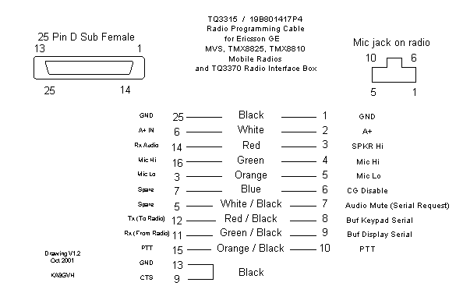
And after further research I ran on to this for the MLS-II.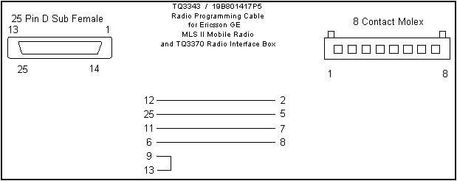
So one can only swap numbers. Like this. Based on both pictures all I did was the following.
From the MVS Rib-less Molex Mic connector I ran tiny wire lead such as the ones you find on computer power cables that supply power to the HD, DVD drives etc.( I have a few useless PC power supplies laying around) Now try to dislodge the cable leads from the connector as you will see that they will fit nicely into the individual pin connectors in the back of the GE MLS radio and in the other end you will have to cut them to the desired length and strip the tips and twist them tight because you will have to stick them into the holes of the Rib-less MVS programmer Molex connector. Now all you have to do is look at picture number one to find the layout of the MVS Molex connector and the MLS-II of the Rib-less programmer and plug as follows.

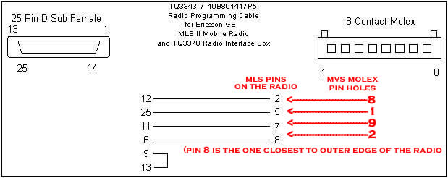
As with any type of electric/electronic connections, do not let the wires come into contact with each other.
I understand that you would have to tune the radio if you want to get to the Ham bands and that goes for the 2 Meters as well as the .70 cm. I don’t know how to do it as I will use my radio for the GMRS band. It would be nice if someone can post instructions on how to tune to include a list of equipment needed or at least give access to the maintenance manuals for the MLS-II. Once you got everything plugged in you can run the software MLS2.0 which you can find in the yahoo groups for GE and radio-programming. Happy programming. I hope this document saves you 40 bucks + shipping and the waiting time to get it in the mail.

Ki6lnx

