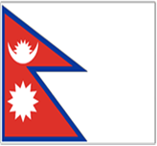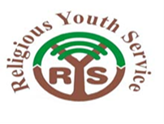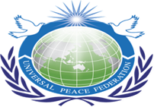
A Service Project supported by UPF
RYS- International Learning Service Project
Dec 2-9, 2012, Kavre, Nepal
Theme
“Building Friendship By Serving Together’
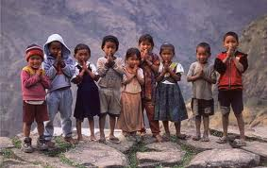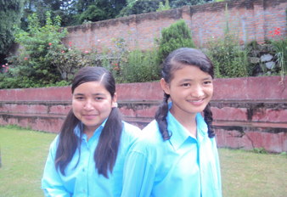
Partners and Supporters:
Kavre Sub- Municipality,
Kavre Transportation Association
Chandeshwori Cooperatives
Ministry of Cooperatives and Poverty Alleviation
Bahai Center - Nepal
Inter-religious Council Nepal
Caritas Nepal
National Inter-religious Network
Step Nepal
District Administration Office, Dhukikhel
Sri Lankan Embassy

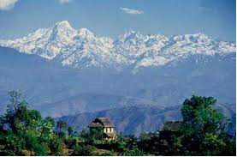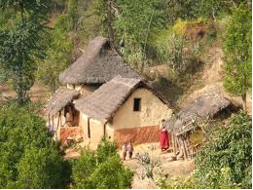
PANORAMIC VIEW OF KAVRE

Project Date : 2-9 December, 2012
Location : Orphan Home. Kavre, Nepal
Project Work : To Renovate the Metta Center Orphan Children Home Building and to Build Peace Wall around it.

International Learning Service Project
RYS has organized several RYS local service project for more than a decade in Nepal bringing youth from around the world especially from Asian Nation, USA, Europe, Korea, Japan and Nepal. And we are glad to have more regular service project in Nepal so that youth will get ample opportunities to exercise their talents and experiences.
RYS Projects has been known among many youths, FBO organization, NGOS, Government and the people of Nepal for its unique components as
- Community based service project
- Value Education, Leadership Training Program
- Inter-faith Visits and Dialogue
- Cross cultural Learning Experience
- Volunteer Service Opportunity

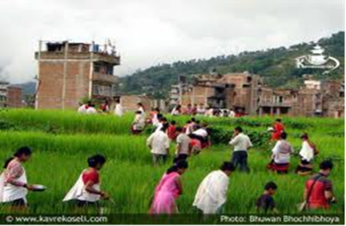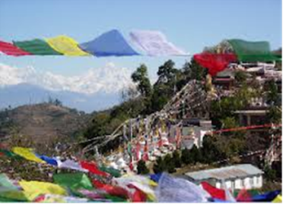

Role of RYS in Nepal
RYS Nepal in its continuous effort in promoting peace and harmony through service projects in Nepal and since 2003 RYS Nepal has been organizing such service projects in different parts of Nepal. It has been one of the most successful result oriented service projects ever in Nepal.
Religious Youth for Peace
Religious Youth Service is creating a youth generation for the past decade in Nepal who are religious minded dynamic socio spiritual oriented people and with this group we can lay a for sustainable peace and development. This is exactly RYS Nepal is doing in producing peace minded youth that live for the sake of others rather than themselves.
Project Work 1: To Renovate Orphan Children Home
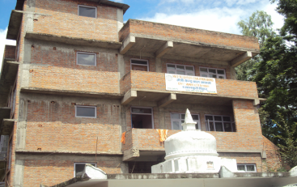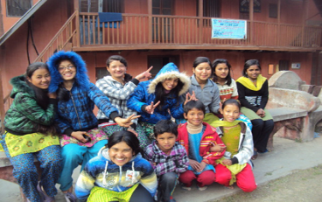
Project Work 2:
To build a wall around Metta Center Children Home
During the project RYS participants will do renovation of the orphan children home building and to build the wall around it. This orphan children and adjourn spiritual and social institute which is the center for educational for people of Banepa and the rest of Nepal.
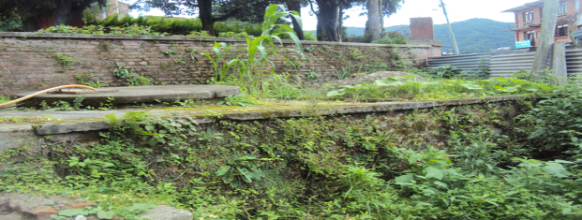
Introduction of Metta Center in Nutshell
Orphan Children Home was established 12 years ago in view to serve conflict affected, orphan, under-privileged children from all over to receive education, food, clothing and full boarding for free. So far more than 50 children got received our services and currently 14 children are residing there coming from all parts of Nepal. And 20 more children are expecting to enroll soon. And we plan to have total 50 children in coming years.
Education Program
Imparting knowledge, providing education and giving training to the RYS participants is the most important segment of RYS Project therefore during the project we will invite different religious leaders, scholars, teachers and NGO for interaction and devotional programs so that young people will have ample opportunity to learn and understand each tradition, culture, faiths so that after the program they can share their experience back to their local communities.

Culture Learning Experience
RYS a role model service project by playing role as a catalyst by creating a common platform for all participants despite their diverse background. Uniqueness of RYS project …is the inter-religious visit at the different religious sites to understand each faith by breaking the religious barriers. At the same time International participants will have chance to learn about the Nepalese culture, tradition, deep rooted religious background and history by visiting local families and community.
Inter-religious Visits
Kavre is connected to high way that leads to Tibet. There are many inter-religious places in Kavre, the world’s tallest Shiva Statues, oldest Buddhist monastery, churches, mosques are situated there along with many tourist attraction.
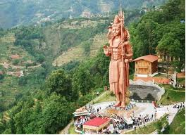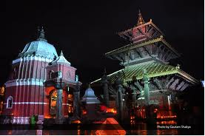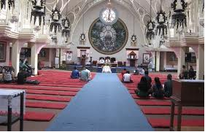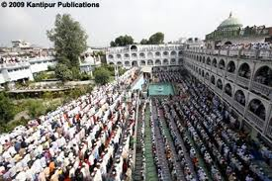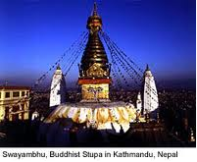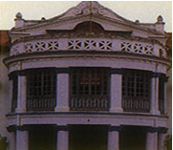
View of different religious sacred places in Kavre and Kathmandu

Impact of the Service Project:
What changes we can make:
Since we work the Municipality and other social institutes in this area the impact will be very positive. And the former Mayor and the local community in this area are happy to see this service project going through in their region. In this way we can make changes at the community level and also the changes within youth participants representing from the different parts of Nepal and the globe.

Benefit Target Group of the project
Metta Center Children Home, Dhyankuti Vihar, and the local community will benefit directly. While all partner organizations will be benefit.
Project Partnership
Our aim is to build strong partnership and look forward working together for the betterment. Therefore, we look forward the interested project partners to make this service project successful.
Your financial support, contribution, volunteering, training, material supports, office support, sponsorship and any forms of support is acceptable.
Total service project cost is USD 11, 764 (Eleven thousand seven hundred sixty five)
Equivalent native currency Nrs 10,0000 ( Ten Lakh)

Facilities Provided During the Project
Free Landline Transportation/food/accommodation will be provided.

Participation Information
We cordially invite the dynamic youth volunteers from local and international to this service project. Participants should be between 16-36 years old.
Number of participant maximum 30

Registration Fees:
For International Participants: USD100
For Regional participants: USD50
For Local participants: NRS.1500
(Please note that your registration fees will go towards building the orphan children home as your personal contribution)

For more information please contact the following addresses:

Piya Ratna Maharjan
Program Director
UPF-Nepal, Peace Embassy Building,
Bhagavati Bahal, Naxal-1, Kathmandu, Nepal.
Tel: 977-1-4444871, 4444872. Fax: 977-1-4444818
Email: rysnepal1@yahoo.com, Mobile: 977-9841228264
Web: www.upf.org/service
Dr. Frank LaGrotteria,
Universal Peace Federation
200 White Plains Road, 1 Floor,Tarrytown, NY 10591, USA
914 631 1331 extension 107Fax: 914 332 1582 Web: www.upf.org/service

