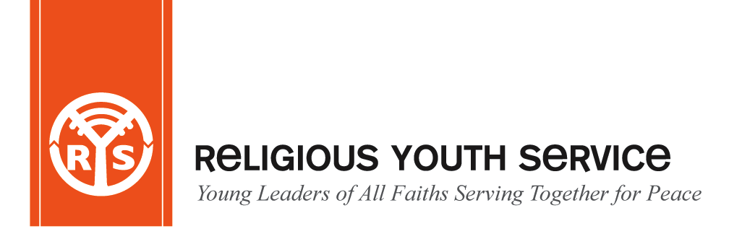
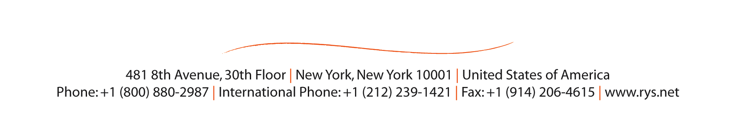
RELIGIOUS YOUTH SERVICE
Banepa Kavre, Nepal
December 2- 9, 2012

REGISTRATION FORM

INSTRUCTIONS: (1)Please type or print legibly
(2) Attach a recent passport size photograph

I. PERSONAL
Name____________________________________________________________________________________________________________
Title First Name Family Name (as given in Passport)

Male ( ) Female ( ) Date of Birth_____________ ___________________Marital Status ____________________________________
Month Day Year

Religious Tradition________________________Current Religion Affiliation______________________Country of Birth________________

Country of Citizenship___________________________________Passport no/date of issue/expiry__________________________________

II. CURRENT MAILING ADDRESS
_________________________________________________________________________________________________________________
City State/Province Postal Code Country

Phone______________________________ Fax____________________ ___________Email_____________________________________

PERMANENT ADDRESS:(if different from the above address) ____________________________________________________________
City State/Province

_________________________________________________________________________________________________________________
Postal Code Country

III. RECOMMENDATION and PREVIOUS EXPERIENCE IN A SERVICE PROJECT
___________________________________________________________________________________________________________________________________________________________________________________________________________________________________________________________________________________________________________________________________________________

IV. DIETARY PREFERENCES

PASSPORT INFORMATION: This information is very important if our office needs to help you obtain a visa. If you are in the process of getting a passport, please send us this information as soon as it is available. If you need an invitation letter please contact Piya Ratna Maharjan at: rysnepal1@yahoo.com

Contact: 810 Peace Embassy Building, Bhagawati Bahal, Naxal-01
Kathmandu Nepal. Tel; 977-1-4444871 email: rysnepal@yahoo.com

