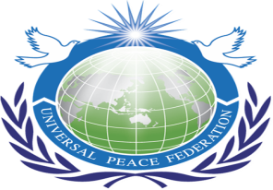
RYS International Voluntary Service Project
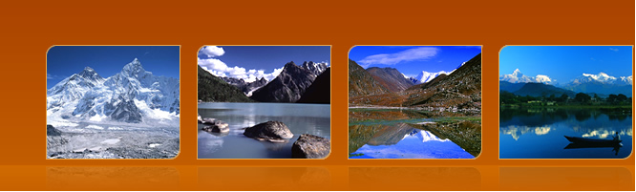
Theme
“Social Transformation through Service”

Project Date : 2-9 June, 2012
Location : Chitlang, Makwanpur, Nepal
Project Work : To build the Library at the Shree Swachanda Bhairav Higher Secondary School and the renovation of the Community Drinking Water

==========================================================
Partnership Project with Shree Swachanda Bhairav Higher Secondary School
Local Village Development under the Ministry of Local Development
Chitlang Local Community and Universal Peace Federation

Introduction of Nepal
Federal Democratic Republic of Nepal is a landlocked sovereign state located in South Asia. It is located in the Himalayas and bordered to the north by the People's Republic of China, and to the south, east, and west by the Republic of India. With an area of 147,181 square kilometers (56,827 sq mi) and a population of approximately 30 million, Nepal is the world's 93rd largest country by land mass]and the 41st most populous country. Kathmandu is the nation's capital.
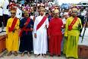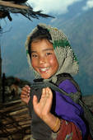
Nepal has a rich geography. The mountainous north has eight of the world's ten tallest mountains, including the highest point on Earth, Mount Everest, called Sagarmatha in Nepali. It contains more than 240 peaks over 20,000 ft (6,096 m) above sea level.^{[7]} The fertile and humid south is heavily urbanized.

RYS Community Based Service Project
RYS has organized several service projects in Nepal on annual basis promoting inter-religious harmony and educating youths representing from different tradition, culture and faiths in Nepal.
RYS Projects has been known among many youths, religious organization, NGOS, government and the people of Nepal for its unique components as
- Community based service project
- Value Education, Leadership Training Program, Peace Education
- Inter-religious Visits, interaction programs and Dialogue with communities
- Cross cultural International Learning Experience
- Volunteer Service Opportunity

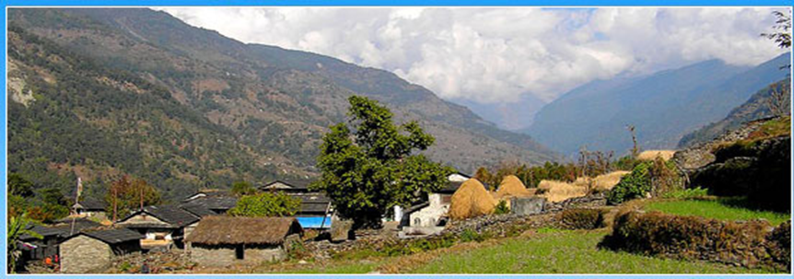

Role of RYS in Nepal
RYS Nepal in its continuous effort in promoting peace and harmony through service projects in Nepal and since 2003 RYS Nepal has been organizing such service projects in different parts of Nepal. It has been one of the most successful result oriented service projects ever in Nepal.
Religious Youth for Peace
Religious Youth Service is creating a youth generation for the past decade in Nepal who are religious minded dynamic socio spiritual oriented people and with this group we can lay for the sustainable peace and development. This is exactly RYS Nepal is doing in producing peace minded youth that live for the sake of others rather than themselves.
About the school and the Need of a Library in Chitlang
Swocchanda Bhairav Higher School was established more than sixty years old. It is one and only higher school in this Chitlang area. Many children walk more than hours every day to go to this school for study since it is the only school that offers class one to college level. More than 550 children are studying there. Though this is higher secondary school in this region and very popular among the local community. Unfortunately there is no library in this school or around this areas ,Therefore, we propose to support building library which is very important component of improving the education standard of the children.

Introduction of the Community Project Site
Community based Project Work 1: To build the Library for school
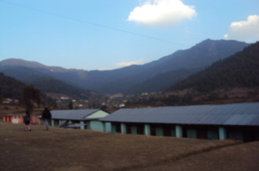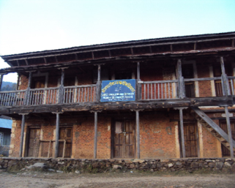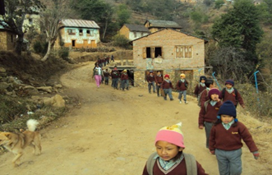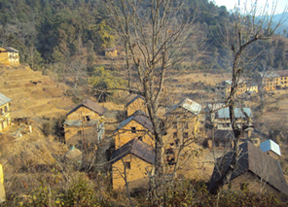

Project Work 2: To renovate Community Water Drinking Work
During the project RYS participants will do renovation of the Community Water tap so that they will have 24 hours drinking water from natural spring water. Also we will support working for the drainage system near the water tap so that water will run smoothly. This will be another significant contribution towards the people of Chitlang for their life improvement.
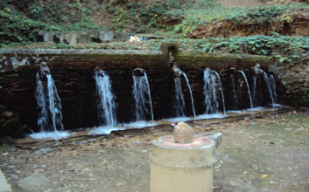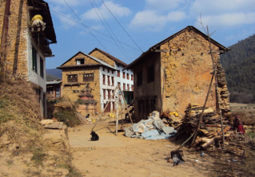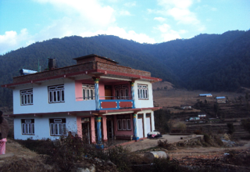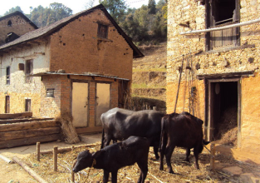
Scenes around project area

Registration
Those who are interested in participating at this service project can apply on line or send their application direct at the following address;
www.rysnet.org. email: rysnepal@yahoo.com
Number of Participants:
- We cordially invite the dynamic youth volunteers from local and international to this service project. Participants should be between 16-35 years old.

Registration Fees:

- International participant US$100
Regional USD$50
Local Rs 1500

RYS – Education Program
Imparting knowledge, providing education and giving training to the RYS participants is the most important segment of RYS Project therefore during the project we will invite different religious leaders, scholars, teachers and NGO for interaction and devotional programs so that young people will have ample opportunity to learn and understand each tradition, culture, faiths so that after the program they can share their experience back to their local communities.
Similarly International participants will have chance to learn about the Nepalese culture, tradition, deep rooted religious background and history by visiting local families and community.
Inter-religious Visits
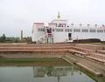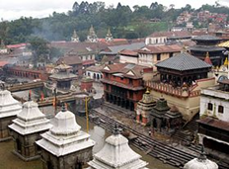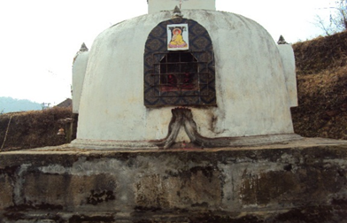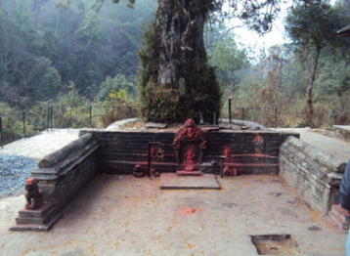

Impact of the Project: What changes we can make:
Chitlang is an emerging tourist destination and yet it is without much development due to geographical location. There are only a few schools and the school we are doing project is only higher school in this area and presently there are more than 550 children are receiving education from this school. With the establishment of library the children, teachers and the researchers will be benefit.
Library is one of most required component of the education and every children needs to read books and until today children in this region are deprived of this facilities. Therefore, making a library will the best gift we can offer to the people of Chitlang Nepal.
Driking Water Project : The community get benefit daily from this works.
Benefit Target Group:
More than 500 school children and youths will get immediate benefits and the children in future. Teachers, visiting scholars, students and the community as a whole will get benefit indirectly. It will be the best gift we can offer this is community.
Project Partnership
Our aim is to build strong partnership and look forward working together for the betterment. Therefore, we look forward the interested project partners to make this service project successful. Those who are interested please contact us for more information.
**************************************************************************
Contact Address:
Piya Ratna Maharjan
Program Director
Peace Embassy Building, Bhagavati Bahal, Naxal-1, Kathmandu, Nepal.Tel: 977-1-4444871, 4444872. Fax: 977-1-4444818Email: rysnepal@yahoo.com, Mobile: 977-9841228264

