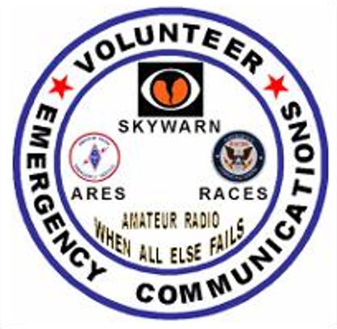

**BROWARD COUNTY FLORIDA**

EMERGENCY COMMUNICATIONS  
Page 2. Looking for an ARES/RACES/SKYWARN Training Officer  
Page 3. Are you what our programs need?   
Page 3. 2014 National Hurricane Conference by Jan, K9JCL  
Page 5. SEVERE WEATHER STORM SPOTTER TRAINING  
Page 6. Broward County ARES/RACES prescribes the Anderson Powerpole  
Page 8. Directions to the Broward County ARES/RACES/SKYWARN Meeting

### Broward County ARES/RACES AND SKYWARN Is Looking For ARES/RACES/SKYWARN Training Officers

### (This Position can be held By One Individual or Three separate Individuals) Training is the most important part of ARES/RACES and Skywarn Communications. Without it the organization will not be able to meet its responsibilities and goals to provide emergency or backup communication when the standard communications is overloaded or non-existent.  A Training Officer can be the key to a good training program.

### This position will be immediately responsible for coordinating the ARES/RACES or SKYWARN training program. Emphasis will be on preparing to provide Emergency Communications for various agencies in our County. Standard Topics shall be covered, such as Personal Conduct, National Incident Management System (NIMS), Independent Study Programs (ISP) FEMA Independent Study Program, Message Handling, Basic Radio Fundamentals, Operations, and Safety are among the various topics.  In this position you will be responsible making sure that someone is going to provide a presentation every month that we meet. Field trips will also be acceptable in place of a meeting.

### Our meetings are held at Broward Health, 1600 S. Andrew Ave in the Oak Room on the third Tuesday of every month. See the map on the last page for directions. With your help, we shall build up the ARES/RACES/SKYWARN program here in Broward County.

### The purpose of ARES®/RACES/SKYWARN is to provide an operational framework from which amateur radio operations can function effectively in support of both Broward County, its Cities Emergency Operation Centers (EOC) and the Red Cross during a major emergency or disaster (natural or manmade).

### By definition, an amateur operator is a person holding a written authorization (FCC license) to be the control operator of an amateur station.

### In the FCC rules and regulations, the definition of Emergency Communication (Part 97, Subpart E) section 97.401 (Operations during a disaster) states the following:

### “When normal communication systems are overloaded, damaged or disrupted because a natural disaster has occurred or is likely to occur in an area where the amateur service is regulated by the FCC, an amateur station may make transmissions necessary to meet essential communication needs and facilitate relief actions.

### Until we fill this vacancies, if you have a topic about amateur radio training, and would like to put on a presentation, please contact us.

BROWARD COUNTY EMERGENCY COORDINATORS  
Robin Terrill, N4HHP 954 249-5343 [n4hhp@arrl.net](mailto:n4hhp@arrl.net) Broward County RACES Officer  
Robin Terrill, N4HHP 954 249-5343 [n4hhp@arrl.net](mailto:n4hhp@arrl.net) Broward County Skywarn Coordinator  
Carol Sjursen, 954 803-6338 [kj4awb@arrl.net](mailto:kj4awb@arrl.net) Broward County ARRL Emergency Coordinator

### Amateur Radio Operators Your Community Needs You!

### If you are an Amateur Radio Operator and would like to help Broward County with back-up emergency communications in shelters, special care facilities, hospitals, EOC’s and other areas where communications is overloaded or non-existent, then you need to contact us. We also have Communications Away Teams (CAT) for those qualified operators who have the desire to provide communication in those areas outside our county in devastated areas where communications is totally non-existent.

### Since it is a known fact that when all primary communications, such as the public telephone, cell phone, police, fire, and other public service agency communications are disrupted do to overloading their service do to man-made or natural disasters, the most reliable communications that can be placed into service in a moment’s notice is amateur radio.

### If you are interested in helping our community, with your skills as an Emergency Radio Operator, please let your intentions be known.

|  |
| --- |
| **Jan Lederman K9JCL would like to share a video with you that he produced and narrated!** |

For those of you that missed the 2014 National Hurricane Conference  
  
<http://animoto.com/play/ZsR6yciFeFAJJAoCfZIsTg>

|  |  |  |
| --- | --- | --- |
| https://responsys.hs.llnwd.net/i5/responsysimages/animoto/Templates_TriggeredEmails/Share/a6.jpg | Watch yourvideo! | https://responsys.hs.llnwd.net/i5/responsysimages/animoto/Templates_TriggeredEmails/Share/a8.jpg |

**An article that may interest you**[Click here: Ham Radio Helping Communities | NickToday Blog](http://nicktoday.com/ham-radio-helping-communities/)

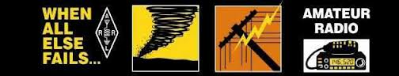

[](http://www.google.com/url?sa=i&rct=j&q=&esrc=s&frm=1&source=images&cd=&cad=rja&docid=AGWMcM4paRkqJM&tbnid=w0i18sMGZHjQxM:&ved=0CAUQjRw&url=http://www.libraryofpoetry.com/contact%20us.html&ei=6BJBUcj0HoyY9QSJsIGIDg&bvm=bv.43287494,d.dmg&psig=AFQjCNEYc0JL7o9tL0h8Go_5vDzC3SQQKA&ust=1363305570147247)  
ARTICLES NEEDED!!!

If you have anything pertaining to ARES/RACES/SKYWARN that you would like to contribute to, and share with others, I would be happy to include your offering in any future edition. I am looking for articles that include hints and kinks, training articles, public service, operating tips etc.  
 **All articles are to be camera ready**. **All articles must be in by the second Tuesday of every month**. **Copyright rules and permission apply to all submissions**. Please send your submission to:

**  **Robin / N4HHP Editor [n4hhp@comcast.net](mailto:n4hhp@comcast.net)**   
  
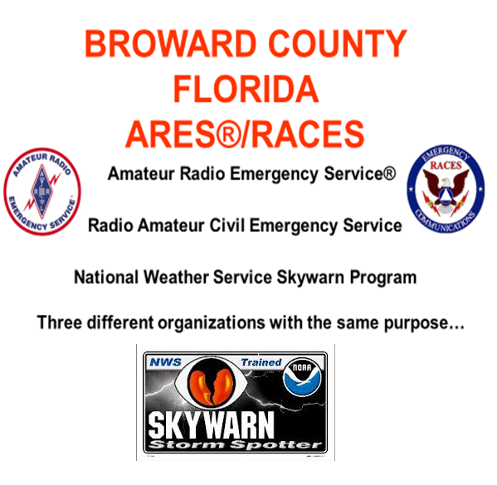  
  
  
 Not a member? It doesn't matter.  
 **You’re welcome to attend our meetings** **No strings, no pressure!**   **SEVERE WEATHER STORM SPOTTER TRAINING**

THIS IS UNDER THE AUSPICES THE BROWARD COUNTY EMERGENCY MANAGEMENT DIVISION BROWARD COUNTY, FLORIDA AND THR NATIONAL WEATHER SETVICE IN MIAMI-DADE FLORIDA.

The National Weather Service (NWS) has a number of devices for detecting severe thunderstorms. Included in these are radar, satellite, and lightning detection networks. However, the most important tool for observing thunderstorms is the trained eye of the storm spotter.

Broward County Storm Spotter is a function of the National Oceanic and Atmospheric Administration's (NOAA), National Weather Service (NWS) designed to record and report hazardous, severe, or unusual weather conditions to the NWS through the use of an Amateur Radio Net. This net is used to provide the NWS with timely and accurate weather observations directly via Ham Radio. This includes both incoming reports of severe weather per the NWS criteria and observations from a specific area made in response to a NWS request. This net is conducted on the 146.31/91 Repeater.

As trained spotters, volunteer ham radio operators perform an invaluable service for the NWS. Real-time observations of tornadoes, hail, wind, and significant cloud formations provide a reliable information base for severe weather detection and verification. By providing observations, ham radio operators are assisting NWS staff members in their warning decisions and enabling the NWS to fulfill its mission of protecting life and property, thereby providing citizens of Broward County with potential life-saving information.

VITAL INFORMATION NEEDED FROM STORM SPOTTERS

1. Any Wall Cloud, Funnel Cloud, Tornado or Waterspout. (Confirmed or suspected) 2. Hail (what size is it?). 3. Winds in excess of 50 mph. 4. Rain in excess of two inches per hour. 5. Abnormal or unusual flooding. 6. Any damage caused by severe weather.

PROCEDURES

1. IDENTIFY YOURSELF AND YOUR LOCATION.
2. PROVIDE A BRIEF DESCRIPTION: Wall cloud, funnel cloud, tornado or waterspout, etc.
3. LOCATION: The direction and distance from a known landmark and/or major intersection.
4. TIME SPOTTED: Please make sure you note the exact time of your observation.
5. BRIEF DESCRIPTION OF ACTION: Describe the storm's direction of travel, size, intensity, and destruction. Include any of uncertainty such as "funnel cloud, no debris visible, too far away to tell it is on the ground." When estimating movement, don't use the motion of small cloud elements. Instead, observe the storm as a whole for estimates of motion.

TIPS FOR STORM SPOTTERS

WIND SPEED: 25 - 31 MPH Large branches in motion: whistling in telephone wires. 32 - 38 MPH Whole trees in motion. 39 - 54 MPH Twigs break off of trees, wind impedes walking.. 55-72 MPH - causes damage to TV antennas, shingles torn off roofs, shallow rooted trees blown over. 73-112 MPH- Roofs blown off, windows broken, mobile homes moved/overturned. 113-157 MPH - Roofs torn off houses, mobile homes demolished, large trees uprooted.

HAIL SIZE: Dime size = 3/4 inch

Quarter size = 1 inch

Golf ball size = 1 3/4 inch

Baseball size = 2 3/4 inch

WHAT IS A WATCH?

A watch is a relatively large area in which flash floods, severe thunderstorms, or tornadoes may occur. Watches are usually issued before any severe weather has developed in the area. Severe thunderstorm and tornado watches are typically 70 statute miles either side of a line 200 miles long. The watch is only an indication of where and when the severe weather possibilities are highest and should not be confused with a warning. The NWS Severe Storms Forecast Center issues watches in Miami Florida.

WHAT IS A WARNING?

Warnings are issued for tornadoes, severe thunderstorms, flash flooding, or special marine weather that has already developed and has been reported by spotters or indicated on RADAR. Warnings are issued for relatively small areas in the path of the storm or floodwaters. Severe Thunderstorm, Special Marine, and Tornado Warnings, Special Weather Statements and Radar Summaries are issued from the NWS Office in Miami Florida.

During a watch or warning, the NWS in Miami will issue hourly updated Special Weather Statements and Radar Summaries that help pinpoint the strongest storms.

MODES OF OPERATIONS

* SEVERE WEATHER ALERT: Is defined as a formal net that is activated with the sounding of a stock message from a NOAA WEATHER RADIO. "SEVERE WEATHER ALERT! Skywarn reports are needed from Skywarn Members.
* SEVERE WARNING WEATHER ALERT: Is defined as weather conditions that are favorable for the development of strong or severe thunderstorm activity. No net will be established at this point, however, one or more Storm Spotter Net Control Operators will be monitoring the frequency in readiness for any development of severe weather and the activation of a Storm Spotters Net.
* SEVERE WEATHER WATCH ALERT: Is defined as a severe thunderstorm watch or a tornado watch which has been issued effecting the Broward County area but no severe weather has been reported. This may also occur if reports of heavy thunderstorm activity have been received. This is a standby, informal net in which the net control operator will identify as a Broward County Storm Spotter Net Control. This mode is only used when Broward County is under a severe thunderstorm warning or tornado warning, or if severe weather is spotted and reported by an amateur operator. Please do not report routine weather conditions.

FOR MORE INFORMATION CONTACT...

* Robin Terrill N4HHP Broward County Skywarn Coordinator 954 249-5343
* Carol Sjursen KJ4AWB Broward County Asst. Skywarn Coordinator 954 803-6338
* Jan Lederman K9JCL Broward County Asst. Skywarn Coordinator 954 483-6838
* Broward County Emergency Management Division 201 NW 84 Avenue Plantation Florida 33317 (954) 831-3900
* THE MIAMI NATIONAL WEATHER SERVICE NEXRAD FORECAST OFFICE 11691 SW 17 Street Miami Florida 33165-2149 (305) 229-4528

ACKNOWLEDGMENTS:

* BROWARD COUNTY EMERGENCY MANAGEMENT DIVISION
* BROWARD COUNTY RADIO AMATEUR CIVIL EMERGENCY SERVICE
* U.S. DEPARTMENT OF COMMERCE
* NATIONAL OCEANIC ATMOSPHERIC ADMINISTRATION
* MIAMI NATIONAL WEATHER SERVICE
* MIAMI NEXRAD WEATHER SERVICE OFFICE

|  |
| --- |
| Broward County ARES / RACES Training |

Broward County ARES/RACES prescribes the Anderson Powerpole as the standard dc power connector for use by ARES/RACES personnel. This standard, highly reliable connector allows quick and easy installation and substitution of radios, power supplies, batteries, and other equipment.

Both the 15-ampere or 30-ampere sizes may be used, and both sizes mate with each other. The plastic parts are the same for both sizes. The barrel area (which holds the wire) of the 15-ampere silver-plated contact is smaller than that of the 30-ampere contact, but the contact area is the same. The connectors dovetail together as a compact unit.

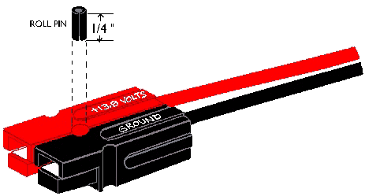

Housings should be mated according to the diagram above, viewing from the contact side (opposite the wire side), tongue down, and hood up, RED on the LEFT, BLACK on the RIGHT. Use a 3/32-inch-diameter roll pin, 1/4 inch long, or a drop of super-glue, to keep the housings from sliding apart.

Highly conductive silver-plated copper contacts allow minimal contact resistance at high currents. Self-wiping action on make and break keeps conducting surfaces clean. Contact dents keep connectors mated in high-vibration applications and provide quick-break, snap action upon disconnect.

Non-corrosive stainless-steel leaf springs maintain constant contact pressure—ideal for frequent connections/disconnections and intermittent overloading. Durable, high impact-resistant, polycarbonate housing with UL94V-2 flammability ratings comes in many colors for circuit trace ability and coding.

Identical connector halves are genderless—making assembly quick and easy and reducing the number of parts stocked. Molded-in dovetails allow for customized harness in a variety of configurations. When the connectors are disconnected, no metal parts are exposed.

The 15-ampere contacts are designed for 16-20 AWG wire and the 30-ampere contacts are designed for 12-16 AWG wire. The contacts can be soldered or crimped to wires. An expensive crimping tool (#1367G1) is available from Anderson. Other, less expensive, crimping tools are available from other suppliers. After a contact has been attached to a wire, it should be installed into the housing so that the housing spring mates with the underside of the contact.

To remove a contact from the housing, use Anderson insertion/extraction tool #111038G2. You may also substitute a very small blade (jeweler's screwdriver or X-acto knife) to depress the spring, allowing the contact to be removed.

Here are the Anderson part numbers:

|  |  |  |  |
| --- | --- | --- | --- |
| **15 A Black Red** | **Complete Connector** #1395G1 #1395 | **Housing Only** #1327G6 #1327 | **Contact Only** #1332 #1332 |
| **30 A Black Red** | **Complete Connector** #1330G4 #1330 | **Housing Only** #1327G6 #1327 | **Contact Only** #1331 #1331 |

WHY BELONG TO ANY OF THESE ORGANIZATIONS?   
**“To provide emergency communications  
before. During, and after**

**Natural or Manmade Disasters”**

***Broward County ARES/RACES***

***3rd Tuesday of the month, at 7:30 P.M. Meeting in the Oak Room.***

**Broward Health (The old Broward General Medical Center)  
1600 South Andrews Avenue, Fort Lauderdale, FL 33316 Meeting is held In The Oak Room**

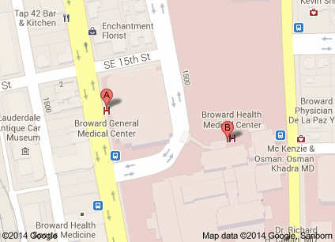

**Parking will be in the 7 story parking garage, (see A Above). The entrance to the building is on the first floor directly across from the parking garage. You will need to go in the main entrance and sign in at the security desk and they will issue you a pass to wear. Bring a driver’s license with you or a picture I.D. Do not by-pass security. They will tell you how to get to the Oak Room.  
  
From I-95 or 595**

**Take I-95 or 595 to SR 84. Go east on 84 until you get to Andrews Avenue turn left (North) until you get to the hospital on your right. 1600 South Andrews Avenue**

**From I-95 to Broward Blvd**

**Take I-95 to Broward Blvd. East on Broward Blvd until you get to Andrews Avenue turn Right (South) until you get to the hospital on your Left. 1600 South Andrews Avenue**

**Talk-in will be on the 146.910 MHz. -600 PL 110.9 Hz.**

**If you get lost or need directions, please call our cell phones:**

**Robin Terrill, N4HHP 954 *249*-5343   
Carol Sjursen, KJ4AWB 954 803-6338  
Jan Lederman K9JCL 954 954 483-6838**

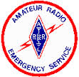 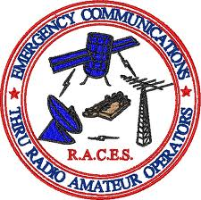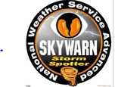 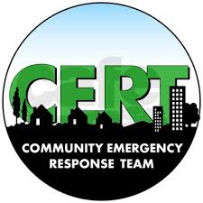  
  
**If you would like to receive this training Newsletter when they come out, please reply to** [**n4hhp@arrl.net**](mailto:n4hhp@arrl.net)