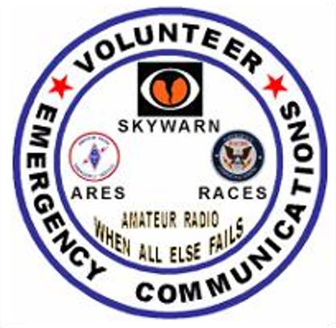

**BROWARD COUNTY FLORIDA**

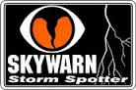EMERGENCY  
 COMMUNICATION  
 TRAINING  
 **Page 2. Broward County ARES/RACES ICS training  
Page 5. It's time of year when strongest twisters form  
Page 6. They’re the first to see bad weather  
Page 7. Why do I need a Weather Radio?  
Page 8. How to make sense of forecasts as hurricane season starts  
Page 9. What is CoCoRahs  
Page 10. Davie Cooper City Amateur Radio Club’s field day  
Page 10. Information about Simplex frequencies  
Page 11. Knights of the Round Table  
Page 12. When all else fails  
Page 13. Since you are an amateur radio operator  
Page 15. 2014 Hurricane Names and 2014 hurricane names  
Page 16. ARES & RACES Application  
Page 17. Directions to our meeting   
  
  
  
Please come to the ARES/RACES meeting on June 17th. We are hosting the Basic Skywarn Class from 7:00 to 9:30 PM. You MUST pre-register for this class. RSVP Robin @** [**n4hhp@comcast.net**](mailto:n4hhp@comcast.net)**. There are only 45 seats available.**

June 2014  
**The Broward County Amateur Radio Emergency Service &   
the Radio Amateur Civil Emergency Service – ICS Training**

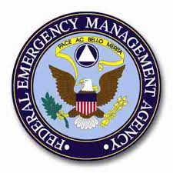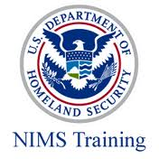

**What is the Incident Command System (ICS) ?**

ICS is the model tool for command, control, and coordination of a response to an incident. By using a common management tool, individual agencies responding to an event may better coordinate the efforts of stabilizing the incident and protecting life, property, and the environment.

**History of ICS**

ICS was developed in the 1970’s in response to a series of wildfires in California. The response to the wildfires identified several problems associated with multiagency response including: nonstandard terminology, difficulty in communicating, and lack of consolidated action plans. During this time local, state and federal fire authorities collaborated and formed the Firefighting Resources of California Organized for Potential Emergencies (FIRESCOPE) to address problems encountered during the wildfire response. FIRESCOPE created the foundation for modern day ICS.

**How is ICS organized?**

ICS organization is built around five major functions: command, operations, planning, logistics and finance/administration. These five components are the foundation upon which the ICS organization is formed. The structure is configured in a pyramid with command at the top of the pyramid and the other functions forming the base.

Operations Section - Planning Section - Logistics Section - Finance/Administrative - Section Incident Commander

**The Command Function**

The incident commander, the person in charge of the incident, directs the command function. The responsibilities of command include: management of the incident, protection of life and property, control of resources, development and implementation of the incident action plan, development and control of the appropriate organizational structure, authorizing the release of information to the media, and tracking costs. In a small event, the incident commander will manage several tasks. In a large event, specific activities may be delegated to other individuals to form a command staff.

**The Operations Section**

The operations section is responsible for the response activities outlined in the incident action plan. An operations section chief manages the operations section. Other responsibilities include: direction, coordination and safety of operations personnel; assistance to the incident commander as requested; and request or release resources at the incident. The operations section chief reports to the incident commander. Should the situation warrant, the operations

Section chief may delegate responsibilities to other operations individuals and further divide the section into other organizational units.

**The Planning Section**

The planning section assists the incident commander is several functions. The planning section is primarily responsible for collection, evaluation, dissemination and information both about the incident and concerning associated resources. This section may also be involved in development of the incident action plan. The Incident Action Plan defines response activities and resource utilization for a specified time period. The planning section is managed by a planning section chief who reports directly to the incident commander. Should the situation warrant, the planning section chief may delegate responsibilities to other planning section individuals and further divide the section into organizational units.

**The Logistics Section**

The logistics section is responsible for providing facilities, services, materials, personnel or other resources necessary to manage the event. This section takes on great significance in long-term or extended operations. The logistics section is managed by a logistics chief who reports directly to the incident commander. The logistics section is further divided into task specific units (ex. Communications) geared to support the incident responders.

ARES/RACES falls under the logistics section – providing a valuable communications resource to the requesting entity.

**The Finance/Administrative Section**

The finance/administrative section tracks incident cost and maintains associated paperwork for reimbursement accounting. Unless costs and financial operations are carefully recorded and justified, reimbursement is next to impossible. The finance/administrative section is managed by a section chief who reports directly to the incident commander. Should the incident warrant, the section may be further divided into organizational units

**Strengths of ICS**

1. Predefined hierarchy, including chain of command and delineated responsibilities for every position

2. Common terminology

3. Modular organizational structure that is expanded or contracted as needed.

4. Incident Action Plans that are updated for each operational period.

5. Manageable Span of Control.

6. Use of standardized forms (213).

7. Ample flexibility and authority given to staff to accomplish objectives.

8. Cross-jurisdictional and cross-functional working relationships when ICS is used.

9. Communications plan that is coordinated among responding agencies.

10. Clear decision-making process.

11. Process for transitioning command authority from one level of government to another as incident complexity changes.

12. Consolidated use of resources.

13. Consistency of implementation across agencies.

**Types of events that may use ICS**

• Fires – Everglades, brush, residential, commercial

• Hazardous materials spills

• Motor vehicle accidents

• Terrorism incidents – biological, chemical, nuclear

• Manmade or natural disasters (i.e. explosive incident hurricanes, tornadoes, flooding, etc.)

• Mass Casualty Incidents

• Large events and festivals

• Field Day

While there is no cost to government or other organizations for our communications service; in certain instances, when a radio amateur is working under the direction of an agency, reimbursement for mileage, meals, and other incidental expenses is acceptable. Worker’s Compensation and/or liability insurance may be provided by a "served agency". This is at the option of the local or state agency or private organization served.

When an order is received by an EC, DEC, SEC, RACES Officer, etc., it is important that they not promise delivery unless they know for sure that they can "deliver the goods" by the time specified. If the time frame is unrealistic, let the person placing the order know. If you as an EC, need to check on the availability of mutual assistance personnel and equipment, before you commit, tell the person when you will "get back to them".

If you can only fill a part of the requested resource, let them know; and ask if that will suffice until you can activate mutual assistance.

|  |
| --- |
| **ICS Training** |

|  |
| --- |
| To help insure that Broward County ARES/RACES can meet the needs of various organizations and agencies that we might work with during an emergency, we are providing various training opportunities for our volunteers.  Below is the minimum training classes that you must have to be considered **NIMS** qualified.  These training programs are available for free on the internet at the following sites.   * IS-100 Introduction to Incident Command System <http://training.fema.gov/emiweb/is/is100.asp> * [IS-200 (ICS 200) ICS for Single Resources and Initial Action Incidents](http://training.fema.gov/emiweb/is/is200.asp)  <http://training.fema.gov/emiweb/is/is200.asp> * [IS-700 National Incident Management System (NIMS), An Introduction](http://training.fema.gov/EMIWeb/IS/IS700a.asp) <http://training.fema.gov/emiweb/is/is700a.asp> * [IS-**802:** Emergency Support Functions (ESF) #2 ...](http://training.fema.gov/EMIWeb/IS/courseOverview.aspx?code=is-802) This course is intended for government executives, private-sector and nongovernmental organization (NGO) leaders, and emergency management practitioners. |

These requirements are in compliance with the requirements of the Department of Homeland Security (DHS) and of the Federal Emergency Management Agency (FEMA) and apply to all potential disaster responders, volunteer and professional.

The listing below merely identifies the various categories of potential responders as they apply to amateur radio.  ARES membership is preferred and recommended but is not an absolute requirement. We also have added the EMCOMM training of the American Radio Relay League. This is not in the DHS/FEMA guidelines but is a League recommendation and one that is being applied in nearly all states in the Country.

Any person not meeting these requirements will not be eligible for deployment, participation, reimbursement, liability protection, etc. Operators that will be deployed locally only or operating at home stations:

Operators likely to be deployed away from their County, ARRL or ARES Officials at the local level (AEC, EC, RACES Officer):

ARRL EC-001 Level 1 Amateur Radio Emergency communications

NIMS IS 100 Introduction to Incident Command System, I-100

****NIMS IS 200 ICS for Single Resources and Initial Action Assessments

NIMS IS 700 National Incident Management System (NIMS)

**An Introduction.**

NIMS IS 802 National Response Plan (NRP): An Introduction is a Web-based awareness level course that introduces the key elements of the National Response Plan so that its implementation can be supported at all levels of government.

Sources:   
ARRL  
FEMA  
Broward County Emergency Management Agency

**It's time of year when strongest twisters Form**

**By Ken Kaye, Staff writer SunSentinel.com, 6:22 p.m. EST, March 8, 2013, (c) 2013, Tribune Interactive, Inc., Ken Kaye**

**We all worry about hurricanes, but tornadoes can spell trouble, too, and few may realize March and April are the time of year they tend to be strongest in South Florida. That's because the atmosphere generates more intense wind shear now, a key ingredient that fortifies twisters, which can spin up with little or no warning. "It's not the same thing as a hurricane, which we can see coming for days," said meteorologist Robert Molleda, of the National Weather Service in Miami. "The warning time for a tornado is sometimes just a couple of minutes, literally." Florida sees 55 tornadoes a year on average – as many as Kansas – with about five of those in South Florida's three counties. Here's what you should know.**

**What's the tornado prediction for this spring?**

**Because spring is expected to be warmer and drier than nor-mal, there likely won't be as many thunderstorms as usual, meaning not as many twisters as usual. But each strong storm holds potential to spawn a tornado.**

**"If the outlook pans out, it would reduce the number of opportunities, but not totally eliminate the threat," Molleda said.**

**Why aren't summer tornadoes as strong?**

**Although tornadoes tend to be more numerous May through August, during the wet season, they usually are short-lived and weaker than those in winter and spring. Even tornadoes that form in the outer bands of tropical systems are more anemic than those at this time of year. Keep in mind, tornadoes can form at any time of year and, because of their capricious nature and capacity for destruction, no twister should be taken lightly, weather officials say. Florida's 55 tornadoes per year ranks third behind Texas (139 per year) and Oklahoma (57). The eight counties that cover the southern third of the state on average see about eight tornadoes, most along the southeast coast**

**How deadly are tornadoes in Florida?**

**Tornado deaths are rare, killing about 200 people in the state since the mid-1800s. Since 1925, winter and spring tornadoes have killed eight people. The last tornado death in South Florida was on March 27, 2003, when a tree branch crashed into a Liberty City home and struck a 67-year-old man.**

**When were South Florida's last tornadoes?**

**In March 2010, a tornado touched down in Oakland Park, cutting a swath of damage from the Lloyd Estates neighborhood to the Northeast Fifth Avenue business district. It downed power lines and damaged a few businesses and a home in the area. In October 2011, a tornado with winds estimated at 130 mph tore through Sunrise and Plantation, damaging more than 130 homes and temporarily leaving more than 1,000 FPL customers without power. There were no serious in-juries. "It looks like a bomb went off over here," Sunrise Mayor Michael Ryan said at the time.**

**How do tornadoes form?**

**Tornadoes usually are born out of the chaotic forces within strong thunderstorms. First warm moist air clashes with cold dry air. Then winds suddenly change directions, creating wind shear, a spin and a funnel cloud that drops out of the sky. In South Florida, tornadoes usually aren't as strong as those in the Midwest because the wind shear isn't as strong. On the other hand, spring twisters here can be similar to those in the Midwest, as both might be born out of powerful thunderstorms formed ahead of cold fronts.**

**Why are tornadoes so dangerous?**

**Tornado winds can exceed 200 mph and be more intense than the most powerful hurricanes. They can uproot trees, lift cars and trucks into the air and destroy homes. Wind-blown debris can become missiles. Over ground, tornadoes can remain almost stationary or race along at more than 50 mph. Their paths can extend a few yards or for many miles. A funnel cloud is a tornado that never touches ground, and waterspouts are tornadoes that form over water.**

**How are the winds measured?**

 **Forecasters can estimate speeds using Doppler radar or by assessing the damage left behind and comparing it against the Enhanced Fujita Scale. For instance, at the low end of the scale, an EF1 tornado with winds of 65 to 85 mph would peel off the roofs of homes and push moving cars off the road. An EF5 with winds greater than 200 mph, would tear homes and buildings off their foundations, and blow cars through the air like missiles. Practically speaking, it’s almost impossible to measure actual winds inside a tornado.**

**Are tornadoes more likely to form at a certain time of day?**

**Twisters in Florida are just as likely to form after midnight as they are in the afternoon, according to the Florida Division of Emergency management. That makes them more dangerous because they might strike while people are sleeping, and wouldn't hear any warnings. The solution: Buy a NOAA Weather Radio, which has a tone alert feature.**

**http://www.sun-sentinel.com/about/site/sfla-copyright,0,6598663.story**

***kkaye@tribune.com or 954-572-2085.***

**They're the first to see bad weather  
  
By Ken Kaye, Staff writer SunSentinel.com, 6:22 p.m. EST, March 4, 2013, (c) 2013, Tribune Interactive, Inc.,**

To predict severe weather, forecasters rely on radar, satellites and computer models. But they also receive help from people gazing out their windows. Maurice Dake has frequently called the National Weather Service to report strong storms, hail and flooding. Once he relayed a report of a tornado blowing a truck off Interstate 95 in northern Palm Beach County.

"That's a problem in Florida," said Dake, of Lake Worth, a retired electrical engineer. "Tornadoes can occur so quickly and move so quickly that you only have a short period of time to report them." Dake is one of about 3,000 weather spotters in South Florida, trained to be on the lookout for tornadoes, strong storms and other severe weather. They try to detect nasty conditions before they happen, allowing the National Weather Service to issue warnings. Sometimes their job is to confirm that a tornado or storm actually formed.

"They're kind of like our eyes and ears in the field," said meteorologist Robert Molleda, who heads up the Skywarn spotter program in South Florida. "We have all the technology. But the only way we know a tornado is forming is by an eyewitness report." The spotters, part of a nationwide network of volunteer observers, come from all walks of life, from attorneys to school teachers. Many are police officers, fire-rescue workers and emergency managers.

The one thing they have in common: They want to help people avoid getting stuck in a stormy situation. No matter where they are, they're constantly scanning the sky, looking for signals that a tornado or a severe thunderstorm is on the verge of forming. Even when the sun is out, many spotters carefully monitor the weather with gauges in their homes that record temperature, wind speed, humidity and rainfall.

Many of the spotters are amateur or "ham" radio operators, experienced at passing along important information during emergencies. For instance, during hurricanes ham radio allows spotters to continue communicating when phone lines are down, said Dake, the Skywarn coordinator for Palm Beach County.

Robin Terrill, the Skywarn coordinator for Broward, has called in numerous severe weather situations, including two water spouts near Port Everglades. He said spotters may call the weather service every week or once every six months.

"If you're at home, you just look outside your window and report what's in your area," he said.

To become a member of Skywarn, prospective spotters must take about four hours of training. The free course, open to anyone 14 or older, covers basic meteorology and emphasizes how to detect bad weather in the making. Something else they learn: Never to risk their safety. "We don't tell people to get in their car and go out into the heart of storm," Molleda said.

For information about upcoming spotter classes in Broward County contact Terrill at n4hhp@comcast.net or in Palm Beach County, Dake at mldake@comcast.net.

|  |
| --- |
| **Why Do I Need a Weather Radio?** |
| |  | | --- | | Weather Radios offer two significant functions. First, they are designed to receive the [NOAA Weather Radio (NWR)](http://www.nws.noaa.gov/nwr/) service's broadcast of weather status and forecasts, providing regular, around-the-clock weather information. Second, they are designed to respond to the [FCC's](http://www.fcc.gov/) [Emergency Alert System (EAS)](http://www.fcc.gov/eb/eas/), which has replaced the older Emergency Broadcast System (EBS), and the alert signals sent by the NOAA Weather Radio service. When the weather radio receives an alert signal, it will respond with an [audible](http://support.radioshack.com/support_tutorials/weather/wr-gde-1.htm) [alarm](http://support.radioshack.com/support_tutorials/weather/wr-gde-1.htm) to attract attention. Many of our weather radios also provide a display that indicates what type of alert is being sent. This allows the user to be alerted to any dangerous situation as soon as possible.  Of particular interest are the portable weather [portable weather radios](http://support.radioshack.com/support_tutorials/weather/wr-gde-8.htm), which have long provided campers, hikers and other travelers with peace of mind and the ready ability to check on the [current](http://support.radioshack.com/support_tutorials/weather/wr-gde-1.htm) weather status.  What does your office conduct its weekly NOAA Weather Radio alert test?  Every Wednesday between 11 AM and Noon is the test of the NOAA Weather Radio tone-alert system and the SAME alert system. This is true all across the country. You can take your NOAA Radio with you on your vacations and business trips. This test is received by the specially built NOAA Weather Radios with the tone-alert and/or the SAME-alert features. People purchasing these radios should use the test to ensure that their radios are functioning properly. Tests of the NOAA Weather Radio warning system will be canceled in situations where hazardous weather and warnings are already present in your listening area or are expected in the next couple hours.  Weather radios can be very helpful during dangerous weather situations. Especially during the night. Not everyone can leave the television on all night, and particularly if you live in [tornado alley](http://www.severe-weather-fan.com/location-of-tornado-alley.html), having a portable weather radio can save your life since many times severe storms and tornadoes hit during the night when everyone is asleep.  So what exactly does a weather radio do? For starters, [NOAA Weather radios](http://www.severe-weather-fan.com/emergency-weather-radio.html) broadcast continuous weather info and alerts people to any special weather watches or warnings throughout the day. The good thing about many weather radios is that you do not need batteries to make a lot of them work. Some use cranks which will generate the power needed to listen, and this is useful when there are power outages because of an [earthquake](http://www.severe-weather-fan.com/earthquake-facts.html), [blizzard](http://www.severe-weather-fan.com/blizzard-fun-facts.html), or [hurricane](http://www.severe-weather-fan.com/facts-about-hurricanes.html).  NOAA weather radios work on the VHF public service band and can be found on these frequencies (note that some also work on AM/FM):  **162.400 162.425 162.450 162.475 162.500 162.525 162.550**  There are a variety of emergency weather radios you can buy. Many come with several features that are very useful. As stated earlier, some weather radios come with crank power which is useful when there is no electricity.  There are many models that also use batteries for their power. Some other features certain radios might include are flashlights. This can be useful during power outages as you can walk and listen at the same time. Some models can also be used as a [cell phone](http://www.severe-weather-fan.com/emergency-weather-radio.html) charger which is pretty handy should you need to call for an emergency and you are not near an outlet or if a power outage has occurred. If you know dangerous weather is on the way, keep your weather radio tuned to the right frequency so it can alert you immediately when there is a weather emergency.  The [NOAA Weather Radio](http://www.nws.noaa.gov/nwr/) network provides voice broadcasts of local and coastal marine forecasts on a continuous cycle. The forecasts are produced by [local National Weather Service Forecast Offices](http://www.nws.noaa.gov/os/marine/marine_map.htm). Coastal stations also broadcast [predicted tides](http://tidesandcurrents.noaa.gov/tide_predictions.shtml)and real time observations from buoys and coastal meteorological stations operated by NOAA's [National Data Buoy Center](http://www.ndbc.noaa.gov/). Based on user demand, and where feasible, Offshore and Open Lake forecasts are broadcast as well.  **COVERAGE**:  The NOAA Weather Radio network provides [near continuous coverage](http://www.nws.noaa.gov/nwr/Maps) of the coastal U.S, Great Lakes, Hawaii, and populated Alaska coastline. Typical coverage is 25 nautical miles offshore, but may extend much  further if necessary.  https://encrypted-tbn3.gstatic.com/images?q=tbn:ANd9GcRVaxu9KSSXGlP6aKwO_MsvjVmIg8FNnE8CBxGbeT8up-VxrqtShttps://encrypted-tbn2.gstatic.com/images?q=tbn:ANd9GcTv4PckkDD-w8YxPO1NGAqgOwwvDLd8GJbDyv_NifPqUuFnFQhttps://encrypted-tbn0.gstatic.com/images?q=tbn:ANd9GcSFnTasyDje4SUBw9kOoSfx0BDQCNrghENXV0cxFWITk7E2XLFISource from Radio Shack and the National Weather Service  [How to make sense of forecasts as hurricane season starts](http://www.sun-sentinel.com/news/broward/fl-hurricane-season-start-20140530,0,3818480.story)  **What Is CoCoRaHS?** <http://www.cocorahs.org/Media/Training/Training_General.htmlCoCoRaHS>  CoCoRaHs is a grassroots volunteer network of backyard weather observers of all ages and backgrounds working together to measure and map precipitation (rain, hail and snow) in their local communities. By using low-cost measurement tools, stressing training and education, and utilizing an interactive Web-site, our aim is to provide the highest quality data for natural resource, education and research applications. The only requirements to join are an enthusiasm for watching and reporting weather conditions and a desire to learn more about how weather can affect and impact our lives.  **For more information, contact Jan Lederman K9JCL *Community Collaborative Rain, Hail & Snow Network***  **Jan Lederman K9JCL hamdogjcl@gmail.com or call 954 483-6838**  **Broward County CoCoRahs Coordinator Broward County Assistant Skywarn Coordinator**    ARTICLES NEEDED!!!  [Description: http://www.libraryofpoetry.com/images/editor.gif](http://www.google.com/url?sa=i&rct=j&q=&esrc=s&frm=1&source=images&cd=&cad=rja&docid=AGWMcM4paRkqJM&tbnid=w0i18sMGZHjQxM:&ved=0CAUQjRw&url=http://www.libraryofpoetry.com/contact%20us.html&ei=6BJBUcj0HoyY9QSJsIGIDg&bvm=bv.43287494,d.dmg&psig=AFQjCNEYc0JL7o9tL0h8Go_5vDzC3SQQKA&ust=1363305570147247)If you have anything pertaining to ARES/RACES/SKYWARN that you would like to contribute to, and share with others, I would be happy to include your offering in any future edition. I am looking for articles that include hints and kinks, training articles, public service, operating tips etc.  **All articles are to be camera ready**. **All articles must be in by the second Tuesday of every month**. **Copyright rules and permission apply to all submissions**. Please send your submission to:  **Robin / N4HHP Editor** [**n4hhp@comcast.net**](mailto:n4hhp@comcast.net)BROWARD COUNTY EMERGENCY COORDINATORS Robin Terrill, N4HHP 954 249-5343 [n4hhp@arrl.net](mailto:n4hhp@arrl.net) Broward County RACES Officer Robin Terrill, N4HHP 954 249-5343 [n4hhp@arrl.net](mailto:n4hhp@arrl.net) Broward County Skywarn Coordinator Carol Sjursen, 954 803-6338 [kj4awb@arrl.net](mailto:kj4awb@arrl.net) Broward County ARRL Emergency Coordinator    Not a member? It doesn't matter  ***You’re welcome to attend our meetings***  No strings, no pressure! *Have A sugestion? contact the* **BROWARD COUNTY EMERGENCY COORDINATORS** | | *SPONSERED BY THE DAVIE COOPER CITY AMATEUR RADIO CLUB*http://www.larkfield.org/images/fieldday_header.jpg *MARKHAM PARK PAVILION 1 Starts Friday June 27 for camaraderie  setup starts on Saturday June 28 field day begins at 12:00 noon  breakdown 4:00 on Sunday June 29* **For more information contact President Buz/N1BUZ at 954 655-6164** | |

**(The information about simplex communications is targeted to the new comer in amateur radio)  
 (The old timers may also learn a thing or two)**

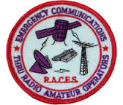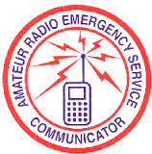 **This training information will also serve both the ARES, RACES & Skywarn members of Broward County**  
  
If amateurs take repeater systems for granted and depend on them, ARES/RACES is less able to respond during an emergency.  If one or more repeaters go off the air due to power failures, remaining ones become overloaded.  It is difficult to coordinate County activities if everyone uses the same few repeaters!

Simplex communications training is very important because we practice our communication skills in anticipation that some or all repeaters may be unavailable due to a man-made or natural disasters. When a disaster strikes, amateurs should check-into the established Broward County ARES/RACES frequency of 146.910 – 600 PL110.9, the Broward Amateur Radio Club’s repeater. When the repeater is “down”, everyone should go to the repeater output frequency which is 146.910 simplex, because that’s where people will be listening. The purpose of doing this is so everyone will be on one established frequency and if and when the repeater starts up again, then all you would have to do is change back to duplex. Remember that simplex is simplex! Why move to another simplex frequency when you are already there?

Amateur radio emergency plans must be implemented when simplex is appropriate and provide guidance on frequency coordination, to manage operations without depending upon repeater infrastructure.

Training in how to use a simplex frequency:

* Hand held transceivers are not adequate as primary rigs for emergency communications!  If an HT signal is so weak that it cannot be copied, it takes double the air time and battery consumption from others to provide relays, repeats or fills.
* **Radio transmissions are usually limited to "line of sight" between station antennas. Line of sight simply means that there is a "radio horizon" from your antenna stretching out to the earth's horizon or other structures which normally blocks or attenuates the radio signals. An analogy would be if you imagine your radio signal as a light beam reaching out to the other station's antenna, so anything in the way of your "light beam" would tend to block or shield it from the other station' antenna and vice versa. Some factors involved in the blocking, or attenuating the signals are tall buildings with lots of metal in them, trees, local "ground clutter" near you with a combination of everything mentioned above. Think of it this way. Assume an HT in the International Space Station (ISS) next to a window facing the Earth with no obstructions! Its line of sight at 200 miles (1,056,000 feet) above the Earth would be about 1,456 MILES! Now how’s that for a line of sight distance using simplex?**
* **When using a handheld, you can sometimes improve your results by moving horizontally a few feet or sometimes just a few inches. This is due to "shadowing" or shielding of objects between you and the other station. Try tilting your handheld radio one way or the other from vertical. It is best if both stations use the same position for their antennas relative to the ground. In other words, if your antenna is at 45 degrees relative to the ground when transmitting, then the station on the other end should be the same. Experiment with the position of the antenna on both ends of the conversation for best results. Try increasing your range by adding the "missing" part of your HT antenna! One simple method of increasing your HT range and performance is to add a "pigtail" or missing part of the antenna to the "rubber duck". Just attach the wire hanging down from the metal connector base of the HF antenna where it attaches to the radio.**  **For 2 meter operation, about 19 to 20 inches should do it. It will really improve your signal in most cases!** [See this link for more info](http://www.hamuniverse.com/htantennamod.html)**.**

**So how do you know if you can use simplex with a station you are hearing?**

* **One good method of knowing if you could contact a particular station directly using simplex would be to listen to the repeater's input frequency that they are using. If you can hear the station well (when your receiver is tuned to its input frequency), then you are close enough to use simplex with that particular station at that point in time! The station you are listening to is transmitting directly to your antenna and also to the input frequency that the repeater is tuned to. It may either be a mobile from their vehicle or sitting back in their favorite chair at home or wherever they may be. If they are mobile, then their signal may be getting stronger or weaker as time passes depending on which direction from you they is traveling. An HT (hand held) transceiver will usually be the same signal strength all of the time if the operator is not moving around, and likewise, a mobile signal will tend to vary if the mobile is moving but usually will not vary if it is stationary.**

2-Meter Simplex Band Plan

|  |  |  |  |  |  |
| --- | --- | --- | --- | --- | --- |
| 146.52* | 146.565 | 147.42 | 147.465 | 147.51 | 147.555 |
| 146.535 | 146.58 | 147.435 | 147.48 | 147.525 | 147.57 |
| 146.55 | 146.595 | 147.45 | 147.495 | 147.54 | 147.585 |

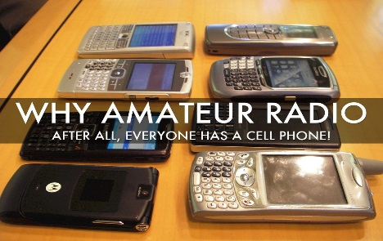**\*** **Note** that the Frequency in RED is also known as the Calling Frequency or the National Simplex Frequency

On simplex, it is important to open the squelch to listen for weak stations, instead of keeping it tight to reduce noise. To get training on how to use a simple frequency, I encourage you to check into the “Knights of the Round Table Simplex Net which meets every Monday starting on either the main 146.550 (no PL tone) simplex frequency or the backup 145.555 (no PL tone) simplex frequency at 7:30 PM. At that time check-ins will be taken and the Rag Chew session will begin.

**Sources from the ARRL, the ARRL Repeater Directory &** Don N4UJW  
73, Robin / N4HHP  
  
When all else fails, ARE YOU ON THE MAP?  
Thank You Jerry Fernandez KK4OXO.

You exemplify The Amateur's Code in which it states "The Radio Amateur is (among other noble characteristics): PATRIOTIC...with station and skill, always ready for service to country and community."

Attached is a photo of our Broward County Simplex Station map constructed by Jerry OXO.  Hopefully you can see the stick pins where stations are located.  OXO created the map to complement his involvement in local a ham club known as the Knights of the Roundtable:   <http://knightsoftheroundtable.info/>    Folks can see exactly where stations are located and, as a result, learn how far away their station, and other stations can hear, and be heard.

Every station is different beginning with equipment ending with antennas.  And it's fascinating to learn about your station, and other stations, our ability to transmit and receive between each other, as well as among each other via relay, what the issues are, how they impact, and what can be done...

The Knights began their Monday evening (19:30 on 146.520 or 145.555) rag chew for fun and education about the world of simplex radio. No question about it, simplex radio is a VERY educational and fun way to learn not just about radio, but potentially even more important, exactly what the world of radio is  going to become WHEN ALL ELSE FAILS.   When The Big One hits, repeaters will surely go down, along with pretty much everything else.  Radio will remain the only sure-fire, fail safe, independent means of communication.

Without repeaters the answer is simple.  The answer is simplex.

WANTED: YOUR LOCATION AND YOUR CALL

Check In! Check It Out!

Get Your Station On The Map!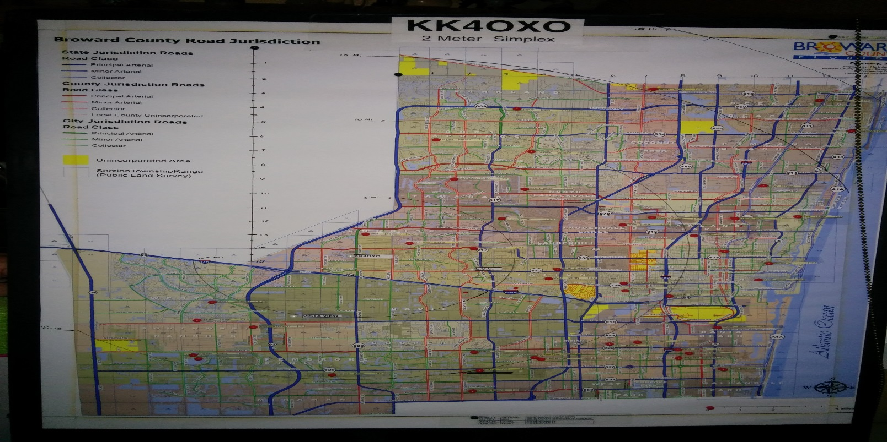  
​  
Sent in by Jan Lederman / K9JCL

|  |
| --- |
| P**Knights of the Round Table [https://sites.google.com/site/flknightsroundtable/_/rsrc/1370315701303/home/RadioRoom.jpg?height=150&width=200](https://sites.google.com/site/flknightsroundtable/home/RadioRoom.jpg?attredirects=0) Why You Should Join Our Group**  **If You Are Interested In Learning More About Amateur Radio Simplex Operation, Then You Are In The Right Location.  The Purpose Of This Site Is To Share Our Common Knowledge On Setting Up Amateur Radio Stations In A Simplex Network That Can Be Operational Following A Natural Disaster When Normal Repeaters May Not Be Functional.  We Provide Information And Training On Radio Equipment, Antennas, And Operational Procedures For Simplex.  So Whether You Want To Be A Member Of Our Group Or Just Casual Viewer Of Our Site, Welcome!**  **We meet each Monday starting on either on our main 146.550MHz (no PL tone) simplex frequency or our backup 145.555MHz (no PL tone) simplex frequency at 7:30PM. At this time we take check-ins and begin our Rag Chew session.**  **If you want to join our Group, just fill out the**[**Registration**](https://sites.google.com/site/flknightsroundtable/radio-location-database)**form with your name, call sign, location (nearest intersecting streets), and radio information.  Then tune your radio to the repeater frequency and check in.** |
|  |

**LIMITED AFTER-ACTION REPORT RELATING TO EVALUATION OF SIMPLEX VHF TRANSMISSIONS BEWEEN RADIO ROOM OF BROWARD COUNTY EMERGENCY OPERATIONS CENTER (EOC) AND AMATEUR RADIO STATIONS.**

* Date of simplex evaluation:  Wednesday, 21 May 2014 (concurrent in time with Statewide Hurricane Jones Functional Exercise).
* Location of Broward County EOC (radio room):  210 NW 84th Avenue, Plantation, Florida 33324.
* Radio call sign of station license for EOC (radio room):  **W4BEM** (hint: BEM = Broward Emergency Management.)
* Frequency used:  146.550 MHz (simplex.)
* Overall evaluation:  very successful.
* Evaluation conducted between 1000 local and 1100 local. (One hour.)
* Thirteen (13) simplex contacts perfectly readable (5/9 to 5/7 and vice versa.)  Two (2) barely readable to unreadable (1/5.)
* Perfectly readable stations:  KK40XX, Jonas; K4ROX, Keith;  K9JCL, Jan;  KP4BM, Jose; KD4ZFW (mobile) Kenny; KJ4FSL, Al (Deerfield Beach EOC) ;  KJ4EGN, Roy; KN4FA, Al (Lauderhill EOC), KK4SVU (mobile), N1TY, Ty;  K2SHA, John, and K4MME, Denise.
* Barely readable stations:  N1RTT, Stan; and (missed unreadable call sign) Sunrise EOC; however both stations good on the Exercise repeater.

Special note:  Within the nine (9) position radio room, two (2) positions were used.  One for the Hurricane Exercise and the other position for the simplex evaluation.  Both positions were operated at the same time, by N4JRW, Steve, and N4JQP, Bob.  This configuration was very beneficial because Steve and Bob were able to coordinate matters between each other while operating on different frequencies.

Special thanks to the Emergency Management division, Jim, Carol, Robin, Steve, and Mike, KM2V, Knights of the Round Table, and the Southeast Florida Traffic Net.

Submitted by:  Robert Hone, N4JQP

**From the RACES Officer: I would like to thank the following for a job well done. Robert / N4JQP, Mike / KM2V,   
Steve / N4JRW, Jim / WB4JC, Carol / KJ4AWB  
What a great Broward County Emergency Operations Center RACES Room Family! Great job all!  
Robin / N4HHP**  
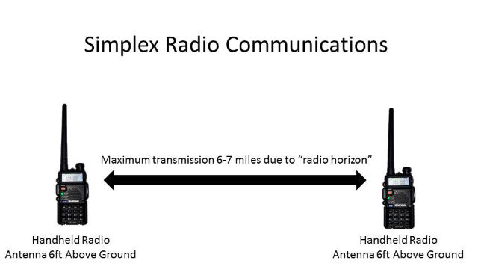 **Line of Sight  
  
  
Since you have your Amateur Radio license  
why not put it to good use!**

**Volunteer today by joining and supporting**

**Broward County  
ARES—RACES—SKYWARN**https://encrypted-tbn1.gstatic.com/images?q=tbn:ANd9GcSFgSgJbkYzdbrawPMvLgnuzoI4F2H17ycSveTHUa5btUlv-7j5 **Severe Weather Spotters  
Hail? Damaging Winds? Flooding?  
If it Matters to you  
It matters to us  
To report severe weather call: The NWS in Miami-Dade County 1 (305) 229-4525  
For Skywarn members please call the 1 (800) number on your Spotters ID Card  
Want to become a Skywarn member, go to** [**http://www.srh.noaa.gov/mfl/?n=skywarn**](http://www.srh.noaa.gov/mfl/?n=skywarn)  
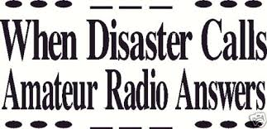

Bottom of Form

# **2014 Hurricane Names**

By [Renee Chapple](http://miami.about.com/bio/Renee-Chapple-8054.htm) From the Miami About.com Newsletter

Have you ever wondered about the system used for naming hurricanes? Where did those names come from, anyway? Will we have to suffer through another "Hurricane Andrew"? The system is not that complicated.

Hurricanes used to be designated by a system of latitude-longitude, which was a great way for meteorologists to track them. However, once the public began receiving storm warnings and trying to keep track of a particular storm path, this got very confusing. A system of names to refer to them was much easier to track and remember.  
  
In 1953, the National Weather Service picked up on the habit of Naval meteorologists of naming the storms after women. Ships were always referred to as [female[http://cdncache1-a.akamaihd.net/items/it/img/arrow-10x10.png](http://miami.about.com/od/weather/a/2014hurricanes.htm)](http://miami.about.com/od/weather/a/2014hurricanes.htm), and were often given women's names. In 1979, male names were inserted to alternate with the female names.

There are actually six lists of names in use for storms in the Atlantic. These lists rotate, one each year; the list of this year's names will not be reused for six years. The names get recycled each time the list comes up, with one exception: storms so devastating that reusing the name is inappropriate. In this case, the name is taken off the list and another name is used to replace it; there will not be another Hurricane Andrew, because Andrew has been replace by Alex on the list.

A storm must start as a Tropical [Depression[http://cdncache1-a.akamaihd.net/items/it/img/arrow-10x10.png](http://miami.about.com/od/weather/a/2014hurricanes.htm)](http://miami.about.com/od/weather/a/2014hurricanes.htm) and move on to become a Tropical Storm before it is given a name. Once a storm is named, [preparations for the possible hurricane](http://miami.about.com/library/weekly/aa061002a.htm) should be well under way. Without further ado, here is the list of hurricane names for 2014:

**Arthur  
Bertha  
Cristobal  
Dolly  
Edouard  
Fay  
Gonzalo  
Hanna  
Isaias  
Josephine  
Kyle  
Laura  
Marco  
Nana  
Omar  
Paulette  
Rene  
Sally  
Teddy  
Vicky  
Wilfred**

One question I've heard a lot recently is "What happens if we [run[http://cdncache1-a.akamaihd.net/items/it/img/arrow-10x10.png](http://miami.about.com/od/weather/a/2014hurricanes.htm)](http://miami.about.com/od/weather/a/2014hurricanes.htm) out of hurricane names?" If we're unlucky enough to deplete the year's supply of names we won't, contrary to popular opinion, simply start using names from next year's list. In that case, the National Hurricane Center will turn to the Greek alphabet and we'll have Hurricanes Alpha, Beta, Gamma, Delta, etc.

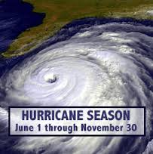  
Atlantic Basin Hurricane Tracking Chart  
National Hurricane Center, Miami, Florida  
[**http://www2.fiu.edu/orgs/w4ehw/atlantic%20tracking%20map%20full%20basin.pdf**](http://www2.fiu.edu/orgs/w4ehw/atlantic%20tracking%20map%20full%20basin.pdf)

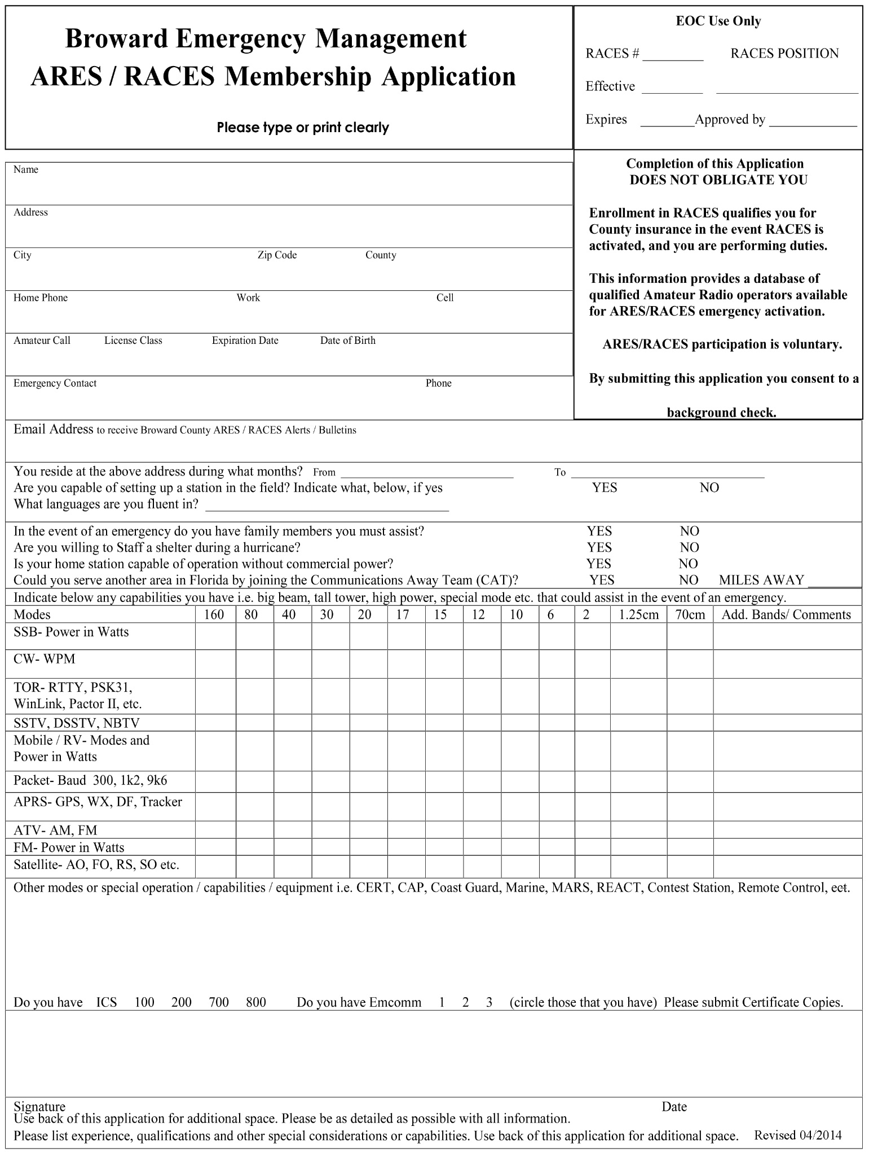

***Broward County ARES/RACES***

***3rd Tuesday of the month, at 7:30 P.M. Meeting in the Oak Room.***

**Broward Health (The old Broward General Medical Center)  
1600 South Andrews Avenue, Fort Lauderdale, FL 33316 Meeting is held In The Oak Room**

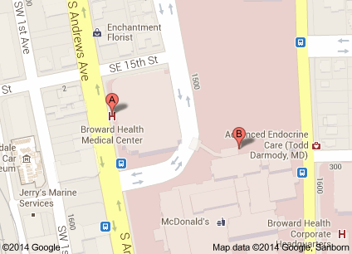

**Parking will be in the 7 story parking garage, (see A Above). The entrance to the building is on the first floor directly across from the parking garage. You will need to go in the main entrance and sign in at the security desk and they will issue you a pass to wear. Bring a driver’s license with you or a picture I.D. Do not by-pass security. They will tell you how to get to the Oak Room.  
  
From I-95 or 595 : Take I-95 or 595 to SR 84. Go east on 84 until you get to Andrews Avenue turn left (North) until you get to the hospital on your right. 1600 South Andrews Avenue**

**From I-95 to Broward Blvd; Take I-95 to Broward Blvd. East on Broward Blvd until you get to Andrews Avenue turn Right (South) until you get to the hospital on your Left. 1600 South Andrews Avenue**

**Talk-in will be on the 146.910 MHz. -600 PL 110.9 Hz.**

**If you get lost or need directions, please call our cell phones:**

**Robin Terrill, N4HHP RACES Officer 954 *249*-5343   
Carol Sjursen, KJ4AWB ARES EC 954 803-6338**

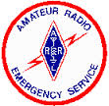 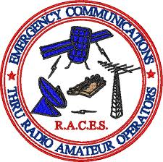 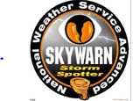 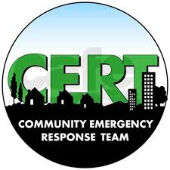 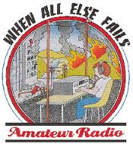  
**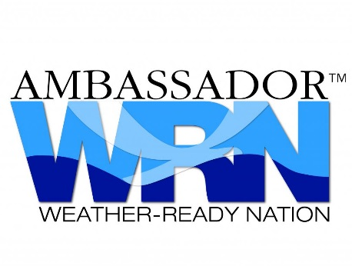  
If you would like to receive this training Newsletter when they come out, please reply to** [**n4hhp@arrl.net**](mailto:n4hhp@arrl.net)