**SATERN QSO Party To Celebrate 150th Anniversary of The Salvation Army**

July 04, 2015 - 12:00 AM EDT  
**Bill Feist**  
bill.feist@uss.salvationarmy.org

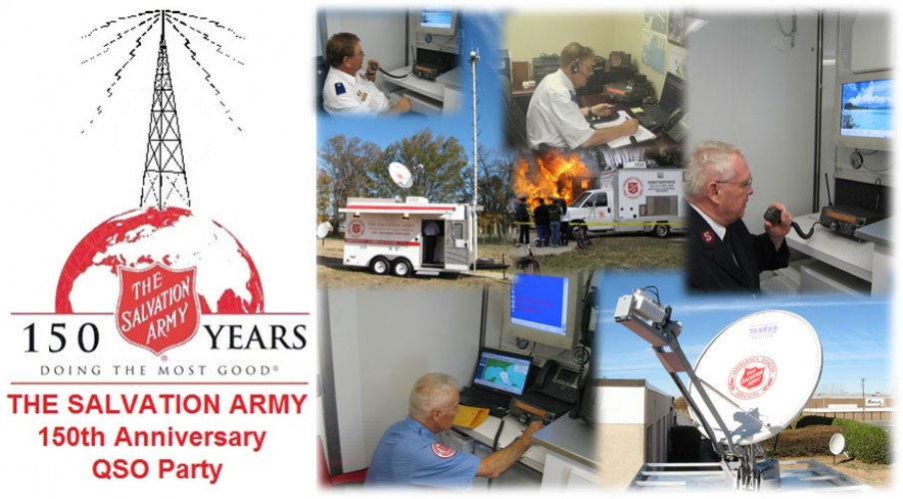

Alexandria, VA (5/14/2015) - The Salvation Army Team Emergency Radio Network (SATERN) will celebrate the 150th Anniversary of The Salvation Army with a Salvation Army 150th Anniversary QSO Party Wednesday, July 1 through Sunday, July 5. 2015.

All amateur radio operators are invited to participate by listening for SATERN stations calling “CQ CQ CQ The Salvation Army 150th QSO Party”.  Those who make contact with a SATERN station from July 1-5 are eligible for a special event QSL card from the participating SATERN station.

SATERN operators interested in participating in The Salvation Army 150th Anniversary QSO Party can access the QSO Party Rules, the downloadable special event QSL card and other resources by opening their personal profile on the national EDS website at disaster.salvationarmyusa.org.  SATERN operators without a personal profile can create one by clicking on the JOIN OUR VOLUNTEER TEAM button in the upper right-hand corner of the national EDS website.  After creating their personal profile, they can then click on the SATERN link under My Settings on the left-hand side of their profile.

The Salvation Army will also celebrate its’ birthday with an International Congress in London on July 1-5, 2015.  It will be attended by Salvationists from all over the 126 countries currently served by The Salvation Army.

The Salvation Army was founded by William Booth, an itinerant Methodist minister who saw that the poor and outcast of Victorian England were not being served by the Church of that day.  He dedicated his life to serving and ministering to those whom society had rejected

On Sunday, July 2, 1865, Booth conducted a simple tent meeting in the very worst part of London.  His preaching and obvious care and concern for those who were poor, marginalized and trapped in that lifestyle by their circumstances impressed wealthy patrons to financially back his ministry and The Salvation Army was born.

The Salvation Army quickly began to have an impact upon the poor and suffering in London and then throughout Victorian England.  Within 15 years, the movement spread to other countries, coming to the United States in 1880.  Within 20 more years it had spread across the North American continent.

In the U.S., The Salvation Army began its’ disaster relief work in 1900 when Galveston, TX, was devastated by a massive hurricane that killed between 5,000 and 8,000 people.  The Salvation Army quickly responded, sending Officers (pastors) and Soldiers (lay members) to Galveston from all over the U.S. to feed and comfort the survivors.  In 1906, The Salvation Army once again responded to disaster – this time to the estimated 8.2 magnitude San Francisco Earthquake.  National Commander Evangeline Booth, daughter of founder William Booth, committed the entire national budget of The Salvation Army in the United States to disaster relief.  When asked how The Salvation Army would continue its’ other work, she replied, “God will provide.”  God did provide and today, The Salvation Army responds to disasters all over the world.

SATERN – the Salvation Army Team Emergency Radio Network - became a part of the EDS ministry in 1988 and has provided international, national and local health & welfare and tactical communication support since then.

The Salvation Army 150th Anniversary QSO Party is being sponsored by a partnership between The Salvation Army National HQ, the Alabama-Louisiana-Mississippi Division of The Salvation Army and the Jackson (MS) Amateur Radio Club.