Neighborhood Damage Assessment Entry Form
To submit a Damage Report follow these steps:
1. | Report the address
Write the address starting with the house number and following with the direction prefix, street name, street type, post direction suffix, city and zip code .
Notice that the direction prefix and direction suffix as well as the street type must be selected from the corresponding drop down list.
 | House number: | Direction: | Street Name: | Street Type: | Dir. Suffix:
 | City: |  |  | Zip:

2. | Select the Damage/Flood Level
From the Damage Level Pictures 1 though 4 shown below, choose the Damage Level and/or Flood Level Number that more closely resembles the damage in the address you are reporting. Then find the number in the Damage and/or Flood level drop down list.
The Flood Level is indicated by the numbers 5 and 6 shown only in picture 1, but it can be also applied to pictures 2, 3, and 4. Flood level 5 demonstrates street flooded or water level onto the property but outside the home, while flood level 6 demonstrates water level inside the home.
The pictures 1 through 4 can be enlarged by clicking with the mouse on them.
 | 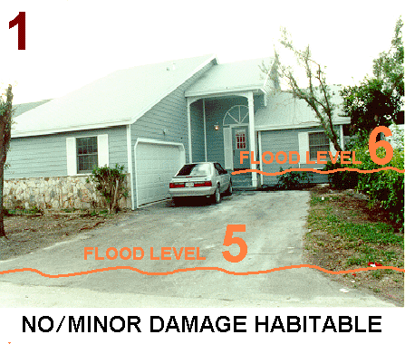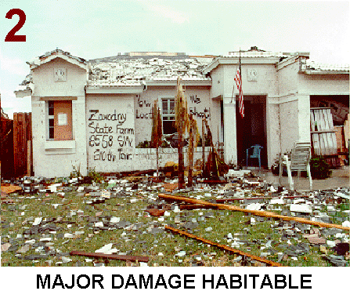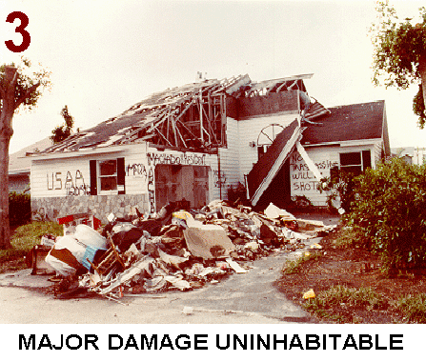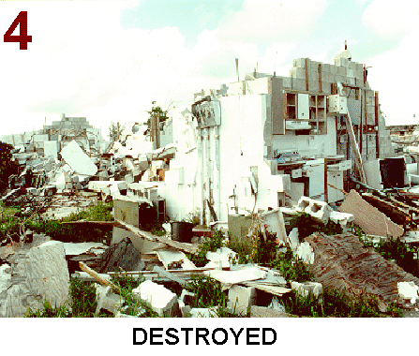
 | Damage level: Flood level:
3. | Submit your Neighborhood Damage Report
 | Please submit your Neighborhood Damage Report by clicking the SUBMIT button. Thank you for your cooperation!

