(Revised October 2017)
“Check-in Procedures if/when There is an Event within Miami Dade County”

RACES/ARES Procedures
- When you are made aware of and event on the commercial Radio stations, TV News, or other means, proceed to the following frequencies for instructions:
1) 146.7000 PL 156.7 offset -6 if this frequency is not operational use the Back-up frequency.
2) (Back-up Frequency) 146.925 Pl 94.8,
At this time check to see if we have been activated to service. Keep checking into frequencies frequently and/or monitor the frequencies.
- There will be RACES/ARES Net control monitoring the frequency to let you know what, or if any information we may have at that time, or to advise you where you may be needed.
- We will make you aware of any short term or long term needs for amateur help.
- Short term you will be asked if you are free to take an assignment
- If the event is a Hurricane -36 hours before the storm- we will have a net controller available to start giving information out at the following times. 0700hrs, 1100hrs, 1800hrs and 2300hrs.

- The net controller will require the following information:
- Will you and your family be riding out the storm at home? If so we will log you in as at your home.
- After the storm Contact net control to let us know if you are safe or in need of help. If we don’t hear from you we will send someone out to check on you to see if you are ok.
- If you and your family are ok and you can take an assignment Please let net control know so we may place you where needed.
- Please also inform us of the status of your n neighborhood , or any other pertinent information using the following format, and keeping all communications concise and to the point :
1. Report the address
Write the address starting with the house number and following with the direction prefix, street name, street type, post direction suffix, city and zip code.
2. Select the Damage/Flood Level
From the Damage Level Pictures 1 though 4 shown below, choose the Damage Level and/or Flood Level Number that more closely resembles the damage in the address you are reporting.
The Flood Level is indicated by the numbers 5 and 6 shown only in picture 1, but it can be also applied to pictures 2, 3, and 4. Flood level 5 demonstrates street flooded or water level onto the property but outside the home, while flood level 6 demonstrates water level inside the home.
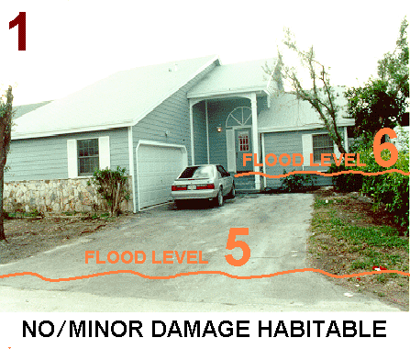

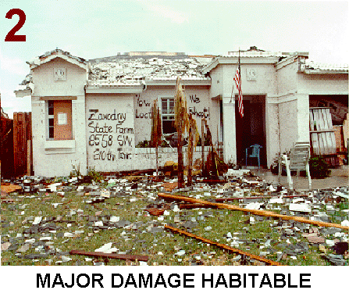

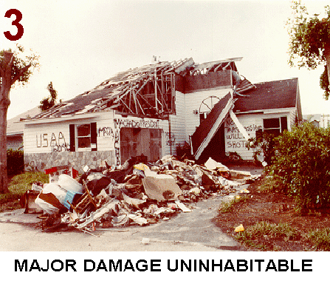

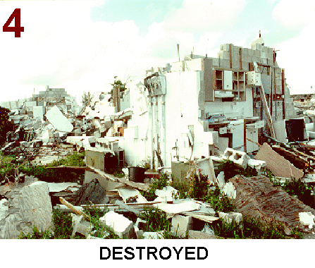

- For reporting of downed power lines and poles, or sparking transformers, please contact FPL directly if possible @ 1-800-4-OUTAGE ( 1-800-468-8243) , otherwise provide the information to the net controller so that it can be relayed to FPL accordingly.

EOC Amateur communication Room Contact Information
EOC Amateur communication room email: hamcomm@miamidade.gov
EOC Amateur communication room telephone numbers:
305 468-5900
305 468-5901

73’s and be safe,
ARES/RACES Team
RACES Officer: Lloyd Kurtzman, N4LJK
Assistant RACES Officer: Robert Hernandez, KM4JAT

